

CITY OF
Ontario
Water, Recycled Water, and Wastewater Financial Plan and Rate Study

Draft Report / April 30, 2025

This page intentionally left blank to facilitate two-sided printing.

May 1, 2025

Mr. Mike Sigsbee
Utilities Assistant General Manager
City of Ontario
303 East B Street
Ontario, CA 91764

Subject: Water, Recycled Water, and Wastewater Financial Plan and Rate Study

Dear Mr. Sigsbee,

Raftelis Financial Consultants, Inc. (Raftelis) is pleased to provide this report to the City of Ontario (City) for the Water, Recycled Water, and Wastewater Financial Plan and Rate Study (Study). This report presents the analyses, rationales, and methodologies utilized to determine utility rates that are informed by California Constitution Article XIII D, Section 6 (commonly referred to as Proposition 218).

The study involved a comprehensive review of the City’s current water, recycled water, and wastewater cost requirements to determine rates that meet the City’s objectives. The main objectives that informed the study include:
- Adequately recovering costs to ensure the financial sufficiency of the City’s utilities
- Determining feasible capital financing plans
- Developing long-term financial plans
- Calculating cost of service-based rates for all utilities
- Minimizing customer impacts from changes to the rate structures

We are confident that the proposed rates developed during this study are fair and equitable for the City’s customers. It was a pleasure working with you and your team, and we wish to express our gratitude for the support you and other City staff provided us during the study. If you have any questions, please do not hesitate to call me at 213-262-9308.

Sincerely,
Raftelis Financial Consultants, Inc.

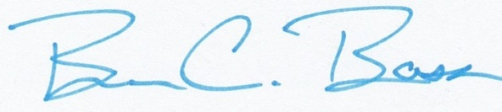

Steve Gagnon, PE Brian Bass
Vice President Manager

This page intentionally left blank to facilitate two-sided printing.

Contents
1. Executive Summary 1

1.1. Study Background 1

1.2. Current Rates 1

1.3. Process and Approach 2

1.4. Results and Recommendations 3

1.5. Proposed Rates 4

1.6. Customer Bill Impacts 5
2. Assumptions 7

2.1. Customer Growth 7

2.2. Revenue Inflation Factors 7

2.3. Expense Inflation Factors 7
3. Water Financial Plan 9

3.1. Projected Demand 9

3.2. Projected Revenues 10

3.3. Projected Purchased Water Expenses 11

3.4. Projected O&M Expenses 13

3.5. Debt Service 13

3.6. Capital Projects 14

3.7. Current Financial Plan – Status Quo 16

3.8. Proposed Financial Plan 19
4. Water Cost of Service 23

4.1. Revenue Requirement Determination 23

4.2. Allocation of Expenses to Cost Causation Components 24

4.3. Units of Service 28
4.3.1. Customer and Meter Equivalents 28
4.3.2. Water Usage and Peaking 29
4.3.3. Cost Distributions to the Cost Causation components 30
5. Water Rate Design 33

5.1. Proposed Monthly Service Charge 33

5.2. Proposed Monthly Private Fire Protection Charge 34

5.3. Volumetric Rates 34
5.3.1. Customer Classes 34
5.3.2. Tier Definitions 34
5.3.3. Commodity Cost Component Definitions 35

5.4. 5-Year Rate Schedule 37

5.5. Customer Bill Impacts 38
6. Recycled Water Financial Plan 39

6.1. Projected Demand 39

6.2. Projected Revenues 39

6.3. Projected Recycled Water Purchase Expenses 40

6.4. Projected O&M Expenses 40

6.5. Debt Service 41

6.6. Capital Projects 41

6.7. Current Financial Plan – Status Quo 41

6.8. Proposed Financial Plan 43
7. Recycled Water Cost of Service 47

7.1. Revenue Requirement Determination 47

7.2. Allocation of Expenses to Cost Components 47

7.3. Units of Service 49
7.3.1. Customer and Meter Equivalents 49
7.3.2. Recycled Cost of Service 49
7.3.3. Recycled Water Rates 51
8. Wastewater Financial Plan 53

8.1. Projection of Customer Data 53

8.2. Projected Revenues 53

8.3. Projected O&M Expenses 54

8.4. Debt Service 54

8.5. Capital Projects 54

8.6. Current Financial Plan – Status Quo 56

8.7. Proposed Financial Plan 59
9. Wastewater Cost of Service and Rates 63

9.1. Process and Approach 63

9.2. Revenue Requirement Determination 63

9.3. Allocation of Expenses to Cost Components 64

9.4. Units of Service 65
9.4.1. Wastewater Cost of Service 66
9.4.2. Wastewater Class Cost of Service 66
9.4.3. Wastewater Rates And Customer Bill Impacts 67

List of Tables
Table 1-1: Current Monthly Water Service Charges ($/meter size) 1
Table 1-2: Current Variable Water Usage Charges ($/hcf of water) 2
Table 1-3: Current Wastewater Rates 2
Table 1-4: Proposed Rate Increases 4
Table 1-5: Proposed Monthly Water Service Charges ($/meter size) 4
Table 1-6: Proposed Water Usage Rates ($/hcf of water) 5
Table 1-7: Proposed Wastewater Rates 5
Table 1-8: Proposed Single Family Customer Monthly Water Bill Impacts (5/8” meter, varying hcf) 5
Table 1-9: Proposed Residential Customer Monthly Wastewater Bill Impacts 6
Table 2-1: Customer Growth Projections 7
Table 2-2: Revenue Inflation Factors 7
Table 2-3: Expense Inflation Factors 8
Table 3-1: Projected Water Accounts and Consumption 10
Table 3-2: Projected Water Revenues (Status Quo) 11
Table 3-3: Projected Purchased Water Expenses 12
Table 3-4: Projected Water O&M Expenses 13
Table 3-5: Existing Water Debt Service 13
Table 3-6: Proposed Water Debt Service 13
Table 3-7: Inflated Water Capital Projects 15
Table 3-8: Proposed Water Capital Financing Plan 16
Table 3-9: Projected Water Financial Plan (Status Quo) 17
Table 3-10: Proposed Water Revenue Adjustments and Bond Issuance 19
Table 3-11: Projected Water Financial Plan (Proposed Revenue Adjustments) 20
Table 4-1: FY 2026 Potable Revenue Requirements 24
Table 4-2: System Peaking Factors, Conversions, and Cost Component Allocations 25
Table 4-3: Potable O&M Allocation Factors 26
Table 4-4: Potable O&M Allocations 26
Table 4-5: Potable Asset Allocation Factors 27
Table 4-6: Potable Asset Allocations 27
Table 4-7: Customer and Equivalent Meter Units 28
Table 4-8: Equivalent Fire Line Units 29
Table 4-9: Class Peaking Factors 29
Table 4-10: Units of Service 31
Table 4-11: Unit Cost of Service 31
Table 4-12: Class Cost of Service 32
Table 5-1: Monthly Fixed Charge Derivation by Meter Size 33
Table 5-2: Monthly Private Fire Charge Derivation by Meter Size 34
Table 5-3: Current Volumetric Tiers 34
Table 5-4: Water Supply Unit Costs 35
Table 5-5: Water Supply Unit Rates 36
Table 5-6: Delivery and Peaking Unit Rates 36
Table 5-7: Volumetric Rate Calculation 37
Table 5-8: 5-Year Rate Schedule 37
Table 5-9: Proposed Single Family Customer Monthly Bill Impacts (5/8” meter, varying ccf) 38
Table 6-1: Projected Recycled Water Demand 39
Table 6-2: Projected Recycled Water Revenues 40
Table 6-3: Projected Purchased Recycled Water Expenses 40
Table 6-4: Projected Recycled Water O&M Expenses 40
Table 6-5: Projected Recycled Water Financial Plan (Status Quo) 42
Table 6-6: Proposed Recycled Water Revenue Adjustments 43
Table 6-7: Projected Recycled Water Financial Plan (Proposed Revenue Adjustments) 45
Table 7-1: Recycled Water Revenue Requirement 47
Table 7-2: Recycled Water O&M Allocation Factors 48
Table 7-3: Recycled Water O&M Allocations 48
Table 7-4: Customer and Equivalent Meter Units 49
Table 7-5: Recycled Water Cost of Service 50
Table 7-6: Recycled Water Meter Charges 51
Table 7-7: Recycled Water Volumetric Charge ($/hcf) 51
Table 7-8: Proposed Recycled Water Service Charge ($/meter size) 51
Table 7-9: Proposed Recycled Water Usage Rates ($/hcf of water) 52
Table 8-1: Projected Wastewater Units and Usage (HCF) 53
Table 8-2: Projected Wastewater Revenues 53
Table 8-3: Projected Wastewater O&M Expenses 54
Table 8-4: Projected Wastewater Debt Issuance 54
Table 8-5: Projected Wastewater Capital Projects 55
Table 8-6: Wastewater Capital Financing Plan 56
Table 8-7: Projected Wastewater Financial Plan (Status Quo) 57
Table 8-8: Proposed Wastewater Revenue Adjustments 59
Table 8-9: Projected Wastewater Financial Plan (Proposed Revenue Adjustments) 61
Table 9-1: Wastewater Revenue Requirement 64
Table 9-2: Wastewater O&M Allocation Factors to Cost Components 64
Table 9-3: Wastewater O&M Allocation to Cost Components 65
Table 9-4: Wastewater Units of Service 66
Table 9-5: Wastewater Cost of Service 66
Table 9-6: Wastewater Class Cost of Service 67
Table 9-7: Wastewater Rate Calculation 67
Table 9-8: Wastewater Rate Forecast Excluding IEUA Rates 67
Table 9-9: Wastewater Bill Impacts without IEUA Passthrough 68

List of Figures
Figure 3-1: Projected Water Financial Plan (Status Quo) 18
Figure 3-2: Projected Water Fund Balances (Status Quo) 19
Figure 3-3: Proposed Water Capital Financing Plan 21
Figure 3-4: Projected Water Financial Plan (Proposed Revenue Adjustments) 22
Figure 3-5: Projected Water Fund Balances (Proposed Revenue Adjustments) 22
Figure 6-1: Projected Recycled Water Financial Plan (Status Quo) 43
Figure 6-2: Projected Water Financial Plan (Proposed Revenue Adjustments) 46
Figure 8-1: Projected Wastewater Financial Plan (Status Quo) 58
Figure 8-2: Wastewater Reserves (Status Quo) 59
Figure 8-3: Projected Wastewater Financial Plan (Proposed Revenue Adjustments) 62
Figure 8-4: Projected Reserves (Proposed Revenue Adjustments) 62

Executive Summary

Study Background
In 2024, the City of Ontario (City) contracted Raftelis to conduct a Water, Recycled Water, and Wastewater Rate Study, which included developing long-term financial plans and cost of service rates. This report presents the three financial plans for each utility for a five-year study period and resulting rates for the water, recycled water, and wastewater utilities for fiscal year (FY) 2026.

This Executive Summary outlines the proposed financial plans and resulting rates and contains a description of the rate study methodology and recommendations. The main objectives that informed the Study include:
- Adequately recovering all costs to ensure the financial sufficiency of the City’s utilities
- Determining feasible capital financing plans
- Developing long-term financial plans
- Calculating cost of service-based rates for all utilities
- Minimizing customer impacts from changes to the rate structures

Current Rates
The City’s current water rates were last updated on July 1, 2024. The monthly water service charges consist of a fixed monthly service charge and a variable monthly water usage charge. Single Family Residential (SFR) customers are charged per 100 cubic feet (hcf) of water, subject to a three-tiered inclining block rate structure. Non-SFR customers are charged at a uniform rate per hcf of water. All recycled water is charged at a uniform rate per hcf of water. The fire service charge is imposed on parcels with a private fire service line serving the parcel, and is a fixed charge based on the size of the private fire meter. Table 1-1 shows the current monthly service charges and Table 1-2 shows the water usage rates by customer class.

Table 1-1: Current Monthly Water Service Charges ($/meter size)
 | A | B | C | D
Line | Meter Size | Potable Water Service Charge | Recycled Water Service Charge | Fire Service Charge
1 | 5/8" | $30.65 | $14.88
2 | 3/4" | $41.01 | $17.20
3 | 1" | $61.84 | $21.85
4 | 1 1/2" | $113.82 | $33.46
5 | 2" | $176.20 | $47.40 | $11.87
6 | 3" | $373.73 | $91.53
7 | 4" | $664.84 | $156.56 | $22.36
8 | 6" | $1,361.40 | $312.18 | $46.17
9 | 8" | $2,505.02 | $567.67 | $87.25
10 | 10" | $3,960.54 | $892.93 | $149.03
11 | 12" |  |  | $234.66
12 | 16" |  |  | $488.93

Table 1-2: Current Variable Water Usage Charges ($/hcf of water)
 | A | B | C
Line | Customer Class | Monthly Tiers (hcf) | Usage Rate
1 | SFR
2 | Tier 1 | 1-10 | $2.40
3 | Tier 2 | 11-18 | $3.82
4 | Tier 3 | Above 18 | $4.59
5 | Non-SFR | Uniform | $3.07
6 | Recycled Water | Uniform | $2.40

The City’s current wastewater rates were last updated on July 1, 2024. The current wastewater rate structure includes a charge from the City of Ontario to operate the local wastewater facilities and a charge to directly pass through costs to treat wastewater by Inland Empire Utilities Agency (IEUA). Rates for residential customers are based on equivalent dwelling units (EDU), while non-residential customers are charged at a uniform rate per hcf of billed water usage. Table 1-3 shows the current rate structure effective July 1, 2024.

Table 1-3: Current Wastewater Rates
 | A | B | C
Line | Customer Class | Ontario | IEUA
 | Residential (per EDU)
1 | Single Family | $14.18 | $24.79
2 | Multi-Family | $11.40 | $17.35
3 | Non-Residential | $1.41/hcf | $24.79

Process and Approach
The City’s rate-setting process involved the participation of and feedback from City staff. During the study, City staff and Raftelis conducted a series of meetings to discuss and understand the challenges the City’s utilities face and to provide guidance to finalize the rate recommendations, which are detailed in this report.

During these meetings, Raftelis presented the various assumptions, inputs, and scenario analyses that were utilized to determine the water, recycled water, and wastewater financial plans. City staff discussed the upcoming capital project requirements, which are main drivers for the revenue adjustments in the final recommendations presented in this report. Raftelis designed and presented the financial planning and rate models to analyze various scenarios, such as those related to debt issuances, revenue adjustments, and capital funding.

The proposed financial plans detailed in this report followed industry standard practices for long-term financial planning and utilize commonly accepted assumptions in the absence of specified assumptions from the City, such as general inflation based on the Consumer Price Index (CPI). Raftelis worked closely with City staff to determine the most accurate methodology to project future revenues and expenses to reinforce sound fiscal management practices.

The cost-of-service analysis utilized to develop the water and wastewater rates followed the guidelines for allocating costs outlined the in American Water Works Association (AWWA) Principles of Water Rates, Fees, and Charges, Manual M1 and in the Water Environment Federation (WEF) Manual of Practice No. 27, Financing and Charges for Wastewater (2018).

The financial plans for the three utilities include the five-year study period from fiscal year (FY) 2026 to FY 2030. The proposed rates were developed for implementation on July 1, 2025 (in FY 2026) and in July of every year thereafter until 2030.

Results and Recommendations
Raftelis worked closely with City staff to define the results and recommendations of the water, recycled water, and wastewater rate study. The recommendations presented in this report will ensure the financial sufficiency and stability of the City’s utilities to fund all necessary operating and capital costs and to maintain sufficient cash balances. To maximize the equity of the rate structures, which is a key objective that informed the study approach, Raftelis recommends that the City retain the current rate structures for the water, recycled water, and wastewater systems.

Water Utility
- The water O&M expenses are expected to increase, on average, by 3.8 percent each year of the study based on the City’s FY 2025 budget and inflationary assumptions.
- The City plans to spend approximately $256 million on capital projects from FY 2026 to FY 2030.
- The City plans to issue debt of $80 million to fund capital expenditures in FY 2028.
- The Study team proposes the annual revenue adjustments shown in Table 1-4 from FY 2026 to FY 2030 to fund capital project spending and to maintain sufficient cash balances.

Recycled Water Utility
- The recycled O&M expenses are expected to increase, on average, by 6.2 percent each year of the study based on the City’s FY 2025 budget and inflationary assumptions. This is primarily due to increases in the cost and volume of purchased water.
- The Study team recommends the annual revenue adjustments shown in Table 1-4.

Wastewater Utility
- The wastewater O&M expenses are expected to increase, on average, by 2.4 percent each year of the study based on the City’s FY 2025 budget and inflationary assumptions.
- The City plans to spend approximately $100 million on capital projects from FY 2026 to FY 2030.
- The Study team recommends the annual revenue adjustments shown in Table 1-4.
Table 1-4: Proposed Rate Increases
A | B | C | D | E | F
Rate Revenue Increases | FY 2026 | FY 2027 | FY 2028 | FY 2029 | FY 2030
Water | 5% | 5% | 9% | 9% | 9%
Recycled Water | 5% | 5% | 9% | 9% | 9%
Wastewater | 5% | 5% | 5% | 5% | 5%

Proposed Rates
Table 1-5 and Table 1-6 show the proposed monthly water service charges and water usage rates for the City’s water and recycled water customers based on the above recommendations. The FY 2026 rates were determined through cost-of-service calculations and FY 2027 through FY 2030 rates were determined by increasing FY 2026 rates by the recommended revenue adjustments.

Table 1-5: Proposed Monthly Water Service Charges ($/meter size)
 | A | B | C | D | E | F | G
Line | Service Charges | FY 2025 (Current) | FY 2026 | FY 2027 | FY 2028 | FY 2029 | FY 2030
 | Potable Water
1 | 5/8" | $30.65 | $29.87 | $31.36 | $32.93 | $35.89 | $39.12
2 | 3/4" | $41.01 | $39.30 | $41.26 | $43.33 | $47.22 | $51.48
3 | 1" | $61.84 | $58.16 | $61.07 | $64.12 | $69.89 | $76.18
4 | 1 1/2" | $113.82 | $105.32 | $110.59 | $116.12 | $126.57 | $137.96
5 | 2" | $176.20 | $161.91 | $170.01 | $178.51 | $194.57 | $212.08
6 | 3" | $373.73 | $341.11 | $358.17 | $376.08 | $409.93 | $446.82
7 | 4" | $664.84 | $605.20 | $635.46 | $667.24 | $727.29 | $792.74
8 | 6" | $1,361.40 | $1,237.13 | $1,298.99 | $1,363.94 | $1,486.69 | $1,620.50
9 | 8" | $2,505.02 | $2,274.63 | $2,388.36 | $2,507.78 | $2,733.48 | $2,979.49
10 | 10" | $3,960.54 | $3,595.08 | $3,774.83 | $3,963.57 | $4,320.29 | $4,709.12
 | Recycled Water
11 | 5/8" | $14.88 | $15.10 | $15.85 | $16.64 | $18.14 | $19.77
12 | 3/4" | $17.20 | $18.35 | $19.26 | $20.23 | $22.05 | $24.03
13 | 1" | $21.85 | $24.85 | $26.09 | $27.40 | $29.86 | $32.55
14 | 1 1/2" | $33.46 | $41.11 | $43.16 | $45.32 | $49.40 | $53.85
15 | 2" | $47.40 | $60.62 | $63.65 | $66.83 | $72.85 | $79.40
16 | 3" | $91.53 | $122.40 | $128.52 | $134.95 | $147.09 | $160.33
17 | 4" | $156.56 | $213.45 | $224.12 | $235.33 | $256.51 | $279.59
18 | 6" | $312.18 | $431.31 | $452.88 | $475.52 | $518.32 | $564.97
19 | 8" | $567.67 | $789.00 | $828.45 | $869.87 | $948.16 | $1,033.49
20 | 10" | $892.93 | $1,244.24 | $1,306.45 | $1,371.77 | $1,495.23 | $1,629.80
 | Fire Service
21 | 2" | $11.87 | $12.78 | $13.42 | $14.09 | $15.36 | $16.74
22 | 4" | $22.36 | $22.01 | $23.11 | $24.27 | $26.45 | $28.83
23 | 6" | $46.17 | $42.99 | $45.14 | $47.39 | $51.66 | $56.31
24 | 8" | $87.25 | $79.16 | $83.12 | $87.27 | $95.13 | $103.69
25 | 10" | $149.03 | $133.57 | $140.25 | $147.27 | $160.52 | $174.97
26 | 12" | $234.66 | $208.99 | $219.44 | $230.41 | $251.15 | $273.75
27 | 16" | $488.93 | $432.92 | $454.57 | $477.29 | $520.25 | $567.07

Table 1-6: Proposed Water Usage Rates ($/hcf of water)
 | A | B | C | D | E | F | G | H
Line | Customer Class | Monthly Tiers (hcf) | FY 2025 (Current) | FY 2026 | FY 2027 | FY 2028 | FY 2029 | FY 2030
 | SFR Potable
1 | Tier 1 | 1-10 | $2.40 | $2.50 | $2.62 | $2.76 | $3.00 | $3.27
2 | Tier 2 | 11-18 | $3.82 | $4.60 | $4.83 | $5.08 | $5.53 | $6.03
3 | Tier 3 | Above 18 | $4.59 | $5.47 | $5.74 | $6.03 | $6.57 | $7.16
4 | Non-SFR Potable | Uniform | $3.07 | $3.44 | $3.62 | $3.80 | $4.14 | $4.51
5 | Recycled | Uniform | $2.40 | $2.49 | $2.61 | $2.74 | $2.99 | $3.26

Table 1-7 presents the proposed City of Ontario wastewater rates. Treatment costs from IEUA will continue to be directly passed through to customers via a charge per EDU.

Table 1-7: Proposed Wastewater Rates
 | A | B | C | D | E | F | G
Line | Customer Class | FY 2025 (Current) | FY 2026 | FY 2027 | FY 2028 | FY 2029 | FY 2030
 | Residential (per EDU)
1 | Single Family | $14.18 | $14.66 | $15.39 | $16.16 | $16.97 | $17.82
2 | Multi-Family | $11.40 | $12.17 | $12.78 | $13.42 | $14.09 | $14.79
 | Non-Residential (per hcf)
3 | All Non-residential classes | $1.41 | $1.50 | $1.58 | $1.65 | $1.74 | $1.82

Customer Bill Impacts
Table 1-8 outlines the proposed customer monthly water bill impacts for a Single Family Residential customer with a 5/8” meter using various amounts of water each billing period. The table compares a bill under the current rate structure to one under the proposed FY 2026 rates. The monthly impact for an average customer using 14 hcf per month will increase by $3.34.

Table 1-8: Proposed Single Family Customer Monthly Water Bill Impacts (5/8” meter, varying hcf)
 | A | B | C | D | E
Line | Single Family Impacts | Water Use (hcf) | Current Monthly Bill | Proposed Monthly Bill | Difference ($)
1 | Very Low Use | 8 | $49.85 | $49.86 | $0.01
2 | Low Use | 12 | $62.29 | $64.07 | $1.78
3 | Average Use | 14 | $69.93 | $73.27 | $3.34
4 | High Use | 23 | $108.16 | $119.03 | $10.87
5 | Very High Use | 30 | $140.29 | $157.32 | $17.03

Table 1-9 outlines the proposed customer monthly wastewater bill impacts for Residential customers. The current and proposed monthly bills exclude the IEUA pass-through charge per EDU. The bills for Single Family and Multi-Family customers will increase as shown in column E.

Table 1-9: Proposed Residential Customer Monthly Wastewater Bill Impacts
 | A | B | C | D | E
Line | Residential Customer | Number of Units | Current Monthly Bill | Proposed Monthly Bill | Difference ($)
1 | Single Family | 1 | $14.18 | $14.66 | $0.48
2 | Multi-Family | 5 | $57.00 | $60.85 | $3.85
3 | Multi-Family | 15 | $171.00 | $182.55 | $11.55
4 | Multi-Family | 20 | $228.00 | $243.40 | $15.40
5 | Multi-Family | 150 | $1,710.00 | $1,825.50 | $115.50
6 | Multi-Family | 175 | $1,995.00 | $2,129.75 | $134.75

Assumptions

The assumptions outlined in this report section are assumptions utilized to project the number of customer accounts, revenues, and expenses for future years. City staff provided data on customer accounts and usage for FY 2024, actual revenues and expenses for FY 2023 to FY 2024, and budget revenue and expenses for FY 2025. The remaining years of the study, from FY 2026 to FY 2030, were projected based on the assumptions shown in this section.

Customer Growth
Table 2-1 shows the customer growth projections for each customer class based on data provided by the City’s planning department. Growth factors are applied to the previous year’s estimate of accounts. Recycled water growth rates are based on the City’s anticipated recycled water customer connections over the forecast period.

Table 2-1: Customer Growth Projections
 | A | B | C | D | E | F
Line | Growth Assumptions | FY 2026 | FY 2027 | FY 2028 | FY 2029 | FY 2030
 | Account Growth
1 | Single Family | 2% | 2% | 2% | 2% | 2%
2 | Multi-Family | 2% | 2% | 2% | 2% | 2%
3 | Commercial | 2% | 2% | 2% | 2% | 2%
4 | Industrial | 0% | 0% | 0% | 0% | 0%
5 | City | 0% | 0% | 0% | 0% | 0%
6 | Irrigation | 0% | 0% | 0% | 0% | 0%
7 | Private Fire | 0% | 0% | 0% | 0% | 0%
8 | Recycled Water | 0% | 7% | 7% | 5% | 5%

Revenue Inflation Factors
Table 2-2 shows the revenue inflation factors used to project future revenues and calculate investment income. Projections assume modest increases in miscellaneous, non-rate revenues throughout the study period because the City is not planning to increase these charges by the same magnitude as rate revenues. The reserve interest rate is used to calculate the investment income based on projected fund balances and is based on conservative estimates in a low-interest financial environment.

Table 2-2: Revenue Inflation Factors
 | A | B | C | D | E | F
Line | Revenue Escalation Assumptions | FY 2026 | FY 2027 | FY 2028 | FY 2029 | FY 2030
1 | Miscellaneous Revenues | 2.0% | 2.0% | 2.0% | 2.0% | 2.0%
2 | Reserve Interest Rate | 0.5% | 0.5% | 0.5% | 0.5% | 0.5%

Expense Inflation Factors
Table 2-3 shows the expense inflation factors used to project future operating and capital project expenses for the study period. These factors were determined with input from City staff. The general inflation factor starts at 7% to reflect the current inflationary environment and decreases to the long-term change in the CPI (inflation). Salary inflation is set to the long-term change in the CPI. Chemical costs follow general inflation and water purchase costs reflect the long-term trend for the City’s various water sources. The capital costs provided by the City already accounted for inflation, so the costs were not escalated by Raftelis.

Table 2-3: Expense Inflation Factors
 | A | B | C | D | E | F
Line | Expense Inflation Assumptions | FY 2026 | FY 2027 | FY 2028 | FY 2029 | FY 2030
1 | General | 7.0% | 5.0% | 4.0% | 3.0% | 3.0%
2 | Salary | 3.0% | 3.0% | 3.0% | 3.0% | 3.0%
3 | Benefits | 3.0% | 3.0% | 3.0% | 3.0% | 3.0%
4 | Chemicals | 7.0% | 7.0% | 5.0% | 4.0% | 3.0%
5 | Utilities | 5.0% | 5.0% | 5.0% | 5.0% | 5.0%
6 | Water Costs | 5.0% | 5.0% | 5.0% | 5.0% | 5.0%

Water Financial Plan

This section of the report details the water enterprise’s long-term financial plan, based on the projected revenues, expenses, debt service, and capital project costs. Raftelis modeled the financial plan without revenue adjustments (status quo) and with proposed revenue adjustments to ensure the financial sustainability and solvency of the water utility.

Projected Demand
City staff provided a count of accounts served and volumes sold for FY 2023 and FY 2024. Raftelis forecasted future accounts using the growth factors presented in Table 2-1. Table 3-1 shows the assumed growth in the number of accounts and consumption.

Table 3-1: Projected Water Accounts and Consumption
 | A | B |  |  |  |  |  | C | D | E | F | G
Line | Accounts and Usage | FY 2025 |  |  |  |  |  | FY 2026 | FY 2027 | FY 2028 | FY 2029 | FY 2030
 | SFR Accounts
1 | 5/8" | 24,642 |  |  |  |  |  | 25,135 | 25,638 | 26,150 | 26,673 | 27,207
2 | 3/4" | 5,404 |  |  |  |  |  | 5,512 | 5,622 | 5,735 | 5,849 | 5,966
3 | 1" | 1,160 |  |  |  |  |  | 1,183 | 1,207 | 1,231 | 1,255 | 1,280
4 | 1 1/2" | 34 |  |  |  |  |  | 34 | 35 | 36 | 36 | 37
5 | 2" | 10 |  |  |  |  |  | 10 | 11 | 11 | 11 | 11
6 | 3" | 0 |  |  |  |  |  | 0 | 0 | 0 | 0 | 0
7 | 4" | 0 |  |  |  |  |  | 0 | 0 | 0 | 0 | 0
8 | 6" | 0 |  |  |  |  |  | 0 | 0 | 0 | 0 | 0
9 | 8" | 0 |  |  |  |  |  | 0 | 0 | 0 | 0 | 0
10 | 10" | 0 |  |  |  |  |  | 0 | 0 | 0 | 0 | 0
11 | Total | 31,250 |  |  |  |  |  | 31,875 | 32,512 | 33,162 | 33,826 | 34,502
 | Non-SFR Accounts
12 | 5/8" | 1,441 |  |  |  |  |  | 1,468 | 1,496 | 1,524 | 1,553 | 1,583
13 | 3/4" | 25 |  |  |  |  |  | 25 | 26 | 26 | 26 | 27
14 | 1" | 1,213 |  |  |  |  |  | 1,234 | 1,255 | 1,276 | 1,298 | 1,320
15 | 1 1/2" | 1,195 |  |  |  |  |  | 1,211 | 1,228 | 1,245 | 1,262 | 1,279
16 | 2" | 2,065 |  |  |  |  |  | 2,091 | 2,118 | 2,145 | 2,173 | 2,202
17 | 3" | 159 |  |  |  |  |  | 161 | 163 | 165 | 167 | 169
18 | 4" | 90 |  |  |  |  |  | 91 | 93 | 94 | 95 | 96
19 | 6" | 43 |  |  |  |  |  | 43 | 44 | 45 | 46 | 47
20 | 8" | 58 |  |  |  |  |  | 59 | 60 | 62 | 63 | 64
21 | 10" | 2 |  |  |  |  |  | 2 | 2 | 2 | 2 | 2
22 | Total | 6,291 |  |  |  |  |  | 6,387 | 6,484 | 6,584 | 6,685 | 6,789
 | Fire Protection Accounts
23 | 2" | 10 |  |  |  |  |  | 10 | 10 | 10 | 10 | 10
24 | 4" | 204 |  |  |  |  |  | 204 | 204 | 204 | 204 | 204
25 | 6" | 439 |  |  |  |  |  | 439 | 439 | 439 | 439 | 439
26 | 8" | 865 |  |  |  |  |  | 865 | 865 | 865 | 865 | 865
27 | 10" | 372 |  |  |  |  |  | 372 | 372 | 372 | 372 | 372
28 | 12" | 11 |  |  |  |  |  | 11 | 11 | 11 | 11 | 11
29 | 16" | 0 |  |  |  |  |  | 0 | 0 | 0 | 0 | 0
30 | Total | 1,901 |  |  |  |  |  | 1,901 | 1,901 | 1,901 | 1,901 | 1,901
 | Water Use (hcf)
31 | SFR | 5,131,119 |  |  |  |  |  | 5,233,741 | 5,338,416 | 5,445,184 | 5,554,088 | 5,665,170
32 | Non-SFR | 7,302,516 |  |  |  |  |  | 7,387,123 | 7,473,421 | 7,561,446 | 7,651,230 | 7,742,811
33 | Total | 12,433,635 |  |  |  |  |  | 12,620,864 | 12,811,837 | 13,006,630 | 13,205,318 | 13,407,981

Projected Revenues
City staff provided the actual FY 2023 and 2024 revenues and budgeted FY 2025 revenues for the water utility, which were used to confirm calculated rate revenues and project miscellaneous revenues for the remainder of the study period. Rate revenues on Line 1 were calculated using the units of service shown in Table 3-1 and the rates shown in Table 1-1 and Table 1-2. Table 3-2 shows the projected water revenues under the status quo.

The City expects increases in water rate revenues for all years of the study as a result of increases in customer accounts and consumption. The interest income (Line 2) is calculated using the reserve interest rate (Table 2-2, Line 2). For the status quo scenario, interest income calculations reflect lower fund balances since there are no revenue adjustments and is $0 beginning in FY 2030 because the ending cash balance is negative. The remaining revenues are inflated using the non-rate revenue inflation factor (Table 2-2, Line 1).

Table 3-2: Projected Water Revenues (Status Quo)
 | A | B | C | D | E | F | G
Line | Revenue | FY 2025 | FY 2026 | FY 2027 | FY 2028 | FY 2029 | FY 2030
1 | Rate Revenue | $63,552,478 | $65,184,643 | $66,203,014 | $67,241,753 | $68,301,266 | $69,381,970
 | Other Revenue
2 | Interest Income | $317,028 | $283,966 | $191,091 | $95,151 | $11,182 | $0
3 | Other Revenues | $2,679,189 | $2,679,189 | $2,679,189 | $2,679,189 | $2,679,189 | $2,679,189
4 | Total Revenue | $66,548,695 | $68,147,798 | $69,073,294 | $70,016,092 | $70,991,637 | $72,061,159

Projected Purchased Water Expenses
The City obtains potable water from four sources: Chino Basin Desalter Authority (CDA), Water Facilities Authority (WFA), San Antonio Water Company (SAWC), and groundwater. CDA, WFA, and SAWC charge a rate per acre-foot (AF). There are also annual fixed charges based on an escalating schedule associated with water from WFA, San Antonio, and groundwater extraction.

Table 3-3 shows the calculation of the purchased water cost to meet the demand forecasted in Table 3-1, plus an allowance for water losses based on historic trends. The amount purchased from CDA is equivalent to the contractual minimum purchase required. Purchases from SAWC are based on shares owned, and water from WFA is based on City estimates. Groundwater extractions account for the remainder of the water required. The projected fixed and volumetric costs for purchasing and producing water are inflated based on estimated water costs (Table 2-3, Line 6) and demand. The volumetric rates (Table 3-3, Lines 16-21) are applied to the volumes purchased (Table 3-3, Lines 4-11); the resulting cost is added to the total fixed charges for water (Table 3-3, Lines 12-15). The total water purchase costs are shown in line 30 of Table 3-3.

Table 3-3: Projected Purchased Water Expenses
 | A | B | C | D | E | F
Line | Water Purchase Cost | FY 2026 | FY 2027 | FY 2028 | FY 2029 | FY 2030
1 | Water Demand (hcf) | 12,620,864 | 12,811,837 | 13,006,630 | 13,205,318 | 13,407,981
2 | Water Produced (hcf) with 4% Loss | 13,146,733 | 13,345,664 | 13,548,573 | 13,755,540 | 13,966,646
3 | Water Produced/Purchased (AF) | 30,181 | 30,637 | 31,103 | 31,578 | 32,063
 | Potable Water Sources (AF)
4 | CDA | 8,533 | 8,533 | 8,533 | 8,533 | 8,533
5 | WFA (Tier 1) | 6,000 | 6,000 | 6,000 | 6,000 | 6,000
6 | San Antonio | 600 | 600 | 600 | 600 | 600
7 | Groundwater | 15,048 | 15,504 | 15,970 | 16,445 | 16,930
8 | Total | 30,181 | 30,637 | 31,103 | 31,578 | 32,063
 | Recycled and Recharge Water (AF)
9 | Recycled Water | 11,730 | 11,965 | 12,204 | 12,448 | 12,448
10 | Recharge Water – Ontario’s Share | 4,000 | 4,000 | 4,000 | 4,000 | 4,000
11 | Recharge Water – Fontana’s Share | 0 | 0 | 3,000 | 0 | 0
 | Purchased Water Rate – Fixed ($/year)
12 | San Antonio | $28,344 | $28,344 | $28,344 | $28,344 | $28,344
13 | IEUA RW | $1,223,424 | $1,288,320 | $1,359,288 | $1,430,520 | $1,573,572
14 | IEUA MEU | $1,223,424 | $1,288,320 | $1,359,288 | $1,430,520 | $1,573,572
15 | Groundwater Assessments | $2,310,000 | $2,425,500 | $2,546,775 | $2,674,114 | $2,754,337
 | Purchased Water Rate – Variable ($/AF)
16 | CDA | $1,155 | $1,213 | $1,274 | $1,338 | $1,471
17 | WFA | $1,425 | $1,471 | $1,518 | $1,566 | $1,717
18 | San Antonio | $296 | $296 | $296 | $296 | $296
19 | IEUA RW | $485 | $520 | $538 | $557 | $613
 | Water Storage Rate – Variable ($/AF)
20 | Recharge Water – Ontario’s Share | $692 | $733 | $755 | $778 | $855
21 | Recharge Water – Fontana’s Share | $741 | $785 | $809 | $833 | $916
 | Purchased Water Cost
22 | CDA | $9,859,199 | $10,352,159 | $10,869,767 | $11,413,255 | $12,554,581
23 | WFA | $8,551,320 | $8,823,667 | $9,105,363 | $9,396,767 | $10,301,899
24 | San Antonio | $206,068 | $206,068 | $206,068 | $206,068 | $206,068
25 | IEUA RW | $7,779,050 | $8,361,592 | $8,668,135 | $9,183,980 | $9,877,378
26 | IEUA MEU | $1,223,424 | $1,288,320 | $1,359,288 | $1,430,520 | $1,573,572
27 | WM GW Assessments | $2,310,000 | $2,425,500 | $2,546,775 | $2,674,114 | $2,754,337
28 | Total | $29,929,061 | $31,457,306 | $32,755,396 | $34,304,704 | $37,267,835
 | Water Storage Costs
29 | Recharged Recycled Water | $2,768,000 | $2,932,000 | $5,446,930 | $3,110,559 | $3,421,615
30 | Total Water Purchase Costs | $32,697,061 | $34,389,306 | $38,202,326 | $37,415,263 | $40,689,450

Projected O&M Expenses
City staff provided the actual FY 2023 and FY 2024 O&M expenses and budgeted FY 2025 O&M expenses for the water utility by department. Table 3-4 shows a summary of the projected O&M expenses for the study period. The expenses for the departments in column A include several categories such as salary, benefits, maintenance, etc., and each line item within that department’s budget is escalated based on the expense inflation factors (Table 2-3). The expenses in the Water Purchase Costs (Line 5) are equal to the amount calculated in Table 3-3 less the amount allocated to recycled water later in this report.

Table 3-4: Projected Water O&M Expenses
 | A | B | C | D | E | F | G
Line | O&M Expenses | FY 2025 | FY 2026 | FY 2027 | FY 2028 | FY 2029 | FY 2030
 | Department
1 | Water Administration | $5,602,002 | $5,946,693 | $6,220,013 | $6,456,899 | $6,651,555 | $6,852,098
2 | Pumping | $8,021,940 | $8,461,436 | $8,860,521 | $9,242,041 | $9,603,215 | $9,978,213
3 | Water Line Maintenance | $9,540,487 | $10,025,478 | $10,432,736 | $10,801,785 | $11,126,170 | $11,460,303
4 | Environmental Engr. | $2,407,553 | $2,531,674 | $2,635,388 | $2,729,025 | $2,810,896 | $2,895,223
5 | Water Purchase Costs | $25,988,958 | $24,918,011 | $26,027,714 | $29,534,191 | $28,231,283 | $30,812,072
6 | Water Resources | $2,068,197 | $2,194,422 | $2,294,591 | $2,381,455 | $2,452,898 | $2,526,485
7 | Customer Services | $2,969,793 | $3,081,913 | $3,186,690 | $3,288,758 | $3,387,420 | $3,489,043
8 | Total | $56,598,930 | $57,159,628 | $59,657,652 | $64,434,153 | $64,263,437 | $68,013,437

Debt Service
The City currently has two existing debt issues for the water utility. Table 3-5 shows the annual payments for the Series 2021 Water Revenue Refunding Bonds and the Series 2024 Water Revenue Refunding Bond.

Table 3-5: Existing Water Debt Service
 | A | B | C | D | E | F | G
Line | Existing Debt Service | FY 2025 | FY 2026 | FY 2027 | FY 2028 | FY 2029 | FY 2030
1 | 2021 Water Rev Refund Bond | $4,087,378 | $4,093,709 | $4,090,549 | $4,086,274 | $4,085,888 | $4,082,997
2 | 2024 Water Rev Refund Bond | $2,945,653 | $3,124,250 | $3,120,750 | $3,125,000 | $3,121,500 | $3,120,500
3 | Total | $7,033,031 | $7,217,959 | $7,211,299 | $7,211,274 | $7,207,388 | $7,203,497

To fund the capital program, Raftelis recommends one new debt issuance in FY 2028. The terms for this debt issuance are assumed to be a 30-year bond at 5.0 percent interest with a 2.0 percent issuance cost. It is assumed an additional reserve fund would not need to be created for the debt. Future debt will be included in the debt service coverage requirement as shown in the financial planning sections. The proposed annual debt service for this bond issue is shown in Table 3-6.

Table 3-6: Proposed Water Debt Service
 | A | B | C | D | E | F | G
Line | Proposed Debt Service | FY 2025 | FY 2026 | FY 2027 | FY 2028 | FY 2029 | FY 2030
1 | Proposed Bond Issue | $0 | $0 | $0 | $80,000,000 | $0 | $0
2 | Bond Proceeds | $0 | $0 | $0 | $78,400,000 | $0 | $0
3 | Annual Debt Service | $0 | $0 | $0 | $5,204,115 | $5,204,115 | $5,204,115

Capital Projects
City staff provided the capital improvement plan (CIP) for the water utility for the study period. Table 3-7 shows the CIP costs for the study period (all CIP numbers from City staff included inflation). The water utility CIP includes two projects related to recycled water (Lines 11-12) and are funded by grants. Projects are funded through a combination of water rate revenues, development impact fees (DIF), cash reserves, grants, and bond proceeds.

Table 3-7: Inflated Water Capital Projects
 | A | B | C | D | E | F | G
Line | Capital Improvement Plan | FY 2025 | FY 2026 | FY 2027 | FY 2028 | FY 2029 | FY 2030
1 | Municipal Service Projects | $300,000 | $300,000 | $300,000 | $300,000 | $300,000 | $300,000
2 | Streets and Engineering Projects | $350,000 | $350,000 | $150,000 | $150,000 | $150,000 | $150,000
3 | Facility Site Security Improvements | $1,501,264 | $650,000 | $650,000 | $250,000 | $250,000 | $250,000
4 | Water Resources Consulting | $50,000 | $50,000 | $50,000 | $50,000 | $50,000 | $50,000
5 | Water System Evaluation Enhancements | $100,000 | $100,000 | $100,000 | $100,000 | $100,000 | $100,000
6 | Water System Planning | $300,000 | $200,000 | $200,000 | $200,000 | $200,000 | $200,000
7 | Water Meter Replacement | $1,751,000 | $1,803,530 | $1,857,636 | $1,913,365 | $2,009,033 | $2,109,485
8 | New Meter Install | $700,000 | $742,630 | $764,909 | $787,856 | $827,249 | $868,611
9 | 13th Street Structural Retrofit | $1,000,000 | $0 | $0 | $0 | $9,000,000 | $0
10 | Water Rights Purchase | $50,000 | $50,000 | $50,000 | $50,000 | $50,000 | $50,000
11 | Euclid Avenue Recycled Water System (multi grant) | $0 | $5,000,000 | $0 | $10,000,000 | $10,000,000 | $0
12 | Euclid Avenue Recycled Water System (multi grant) | $292,113 | $0 | $0 | $0 | $0 | $0
13 | AMI Antenna Tower | $275,000 | $1,125,000 | $0 | $0 | $0 | $0
14 | Pressure Reducing Stations Rehab | $0 | $2,000,000 | $0 | $0 | $0 | $0
15 | Risk and Resiliency | $200,000 | $100,000 | $100,000 | $100,000 | $100,000 | $100,000
16 | Onsite Chlorine Generators | $2,000,000 | $4,000,000 | $0 | $0 | $0 | $0
17 | GroundWater Wellhead Treatment Well 50 | $0 | $0 | $0 | $1,000,000 | $1,000,000 | $0
18 | WM Transit/Emporia/Palm/Laurel | $5,223,176 | $0 | $0 | $0 | $0 | $0
19 | Potable Well No. 53 | $1,500,000 | $3,000,000 | $2,500,000 | $0 | $0 | $0
20 | Wells Maintenance and Repairs | $1,700,000 | $840,000 | $850,000 | $850,000 | $850,000 | $850,000
21 | Downtown Water Main Improvements | $2,438,576 | $0 | $0 | $0 | $0 | $0
22 | Relocation of Water Mains (I-10 Corridor Express Lanes) | $4,089,900 | $0 | $0 | $0 | $0 | $0
23 | Bon View Main Improvements (South of Francis Street) | $1,107,194 | $381,194 | $0 | $0 | $0 | $0
24 | Citywide Water Main Improvements | $10,000,000 | $5,000,000 | $5,000,000 | $5,000,000 | $5,000,000 | $5,000,000
25 | OMSC Bioswale Drainage Imp. | $75,000 | $0 | $0 | $0 | $0 | $0
26 | State Street, Campus, Avenue, Bonview Water Main Imp. | $889,624 | $0 | $0 | $0 | $0 | $0
27 | Advanced Water Purification Facility | $500,000 | $250,000 | $250,000 | $250,000 | $250,000 | $250,000
28 | Reservoir 925 1-A | $339,597 | $15,000,000 | $15,000,000 | $0 | $0 | $0
29 | John Galvin Treatment Plant Improvements | $350,000 | $0 | $0 | $1,000,000 | $0 | $0
30 | New Groundwater Wellhead Treatment Plant | $0 | $0 | $0 | $1,000,000 | $16,250,000 | $0
31 | OMUC Customer Information System | $225,000 | $75,000 | $75,000 | $75,000 | $0 | $0
32 | CDA Booster Station Upgrade | $200,000 | $1,500,000 | $1,500,000 | $0 | $0 | $0
33 | G Street 18" Potable Water Main | $281,000 | $0 | $0 | $0 | $0 | $0
34 | Municipal Service Center Relocation | $800,000 | $800,000 | $0 | $20,400,000 | $19,800,000 | $0
35 | Sports Complex Offsite Utilities Projects Water Imp. | $4,000,000 | $7,360,000 | $4,000,000 | $0 | $0 | $0
36 | Ontario Ranch Phase 2B Water Main | $5,477,935 | $7,385,939 | $7,385,939 | $0 | $0 | $0
37 | Edison and Bonview Water Main Imp | $500,000 | $0 | $2,000,000 | $0 | $0 | $0
38 | New Well XX | $0 | $500,000 | $2,500,000 | $700,000 | $0 | $0
39 | Future 1212 PZ Resv&Main Rochestor TK 31.5 | $0 | $1,500,000 | $18,000,000 | $12,000,000 | $0 | $0
46 | Total Capital Projects | $48,566,379 | $60,063,293 | $63,283,484 | $56,176,221 | $66,186,282 | $10,278,096
47 | Total Potable | $48,566,379 | $60,063,293 | $63,283,484 | $56,176,221 | $66,186,282 | $10,278,096
48 | Total Recycled | $0 | $0 | $0 | $0 | $0 | $0

Table 3-8 shows the proposed capital financing plan for the water utility. The City plans to fund all of its water CIP (Line 3). Capital expenses (Line 5) include utilities and other expenses that are appropriate to capitalize. The bond proceeds are from the proposed debt issuances (Table 3-6, Line 2). The remainder will be funded through rates, capacity fees, grants, sales of existing land, general fund transfers, and DIF reimbursements.

Table 3-8: Proposed Water Capital Financing Plan
 | A | B | C | D | E | F | G
Line | Capital Financing | FY 2025 | FY 2026 | FY 2027 | FY 2028 | FY 2029 | FY 2030
 | Potable Water
1 | Inflated CIP Costs | $48,566,379 | $60,063,293 | $63,283,484 | $56,176,221 | $66,186,282 | $10,278,096
2 | Capital Spending Factor | 100% | 100% | 100% | 100% | 100% | 100%
3 | Total Funded CIP | $48,566,379 | $60,063,293 | $63,283,484 | $56,176,221 | $66,186,282 | $10,278,096
4 | Capital Expenses | $8,002,744 | $8,339,944 | $8,641,129 | $8,900,363 | $9,167,374 | $9,442,395
5 | Total Capital Costs | $56,569,123 | $68,403,237 | $71,924,613 | $65,076,584 | $75,353,656 | $19,720,491
 | Capital Financing Plan
6 | Grant Funded | $0 | $5,000,000 | $0 | $10,000,000 | $10,000,000 | $0
7 | DIF Reimbursement | $7,175,156 | $15,436,238 | $19,385,939 | $6,040,000 | $2,980,000 | $0
8 | Sales of Existing PW Land | $0 | $0 | $0 | $8,160,000 | $7,920,000 | $0
9 | General Fund Transfer for Sports Complex | $4,000,000 | $7,360,000 | $4,000,000 | $0 | $0 | $0
10 | Capacity Fees | $250,000 | $255,000 | $260,100 | $265,302 | $270,608 | $276,020
11 | Proposed Debt Funded | $0 | $0 | $0 | $40,611,282 | $37,788,718 | $0
12 | Potable Pay-Go | $45,143,967 | $40,352,000 | $48,278,574 | $0 | $16,394,330 | $19,444,471
13 | Recycled Pay-Go | $0 | $0 | $0 | $0 | $0 | $0
14 | Total | $56,569,123 | $68,403,237 | $71,924,613 | $65,076,584 | $75,353,656 | $19,720,491

Current Financial Plan – Status Quo
Table 3-9 shows the projected water financial plan without revenue adjustments or proposed bond proceeds (also referred to as status quo). Rate revenues and other revenues are derived from projected revenues (Table 3-2). O&M expenses are derived from projected O&M expenses (Table 3-4), and existing debt service is from the annual debt service payments for outstanding debt (Table 3-5). The status quo scenario assumes no bond proceeds and thus all capital projects are rate funded.

The net cash flow (Line 19) is calculated by subtracting O&M expenses (Line 12) and debt service and capital costs (Line 17) from the total revenues (Line 4). Net operating revenue (Line 20) is equal to total revenues less O&M expenses. Debt coverage (Line 21) is calculated by dividing the net operating revenue by the total debt service (Lines 13-14) and falls below the required debt coverage (Line 22) beginning in FY 2028. Net cash flow is negative for all years of the study, which means that the water utility does not have enough revenues from rates to fund its operating expenses, debt, and capital costs. If there are no revenue adjustments and new debt for the water utility, the fund cash balance (Line 24) will be depleted by FY 2028. Please note that the fund balance for water includes only the Water Operating funds. The reserve target (Line 25) is equal to 25 percent of O&M expenses.

Table 3-9: Projected Water Financial Plan (Status Quo)
 | A | B | C | D | E | F | G
Line | Financial Plan | FY 2025 | FY 2026 | FY 2027 | FY 2028 | FY 2029 | FY 2030
 | Revenues
1 | Rate Revenues | $63,552,478 | $65,184,643 | $66,203,014 | $67,241,753 | $68,301,266 | $69,381,970
2 | Revenue Adjustments | $0 | $0 | $0 | $0 | $0 | $0
3 | Other Revenues | $2,996,217 | $2,963,155 | $2,870,280 | $2,774,340 | $2,690,371 | $2,679,189
4 | Total Revenues | $66,548,695 | $68,147,798 | $69,073,294 | $70,016,092 | $70,991,637 | $72,061,159
 | O&M Expenses
5 | Water Administration | $5,602,002 | $5,946,693 | $6,220,013 | $6,456,899 | $6,651,555 | $6,852,098
6 | Pumping | $8,021,940 | $8,461,436 | $8,860,521 | $9,242,041 | $9,603,215 | $9,978,213
7 | Water Line Maintenance | $9,540,487 | $10,025,478 | $10,432,736 | $10,801,785 | $11,126,170 | $11,460,303
8 | Environmental Engr. | $2,407,553 | $2,531,674 | $2,635,388 | $2,729,025 | $2,810,896 | $2,895,223
9 | Water Purchase Costs | $25,988,958 | $24,918,011 | $26,027,714 | $29,534,191 | $28,231,283 | $30,812,072
10 | Water Resources | $2,068,197 | $2,194,422 | $2,294,591 | $2,381,455 | $2,452,898 | $2,526,485
11 | Customer Services | $2,969,793 | $3,081,913 | $3,186,690 | $3,288,758 | $3,387,420 | $3,489,043
12 | Total | $56,598,930 | $57,159,628 | $59,657,652 | $64,434,153 | $64,263,437 | $68,013,437
 | Debt Service and Capital
13 | Existing Debt Service | $7,033,031 | $7,217,959 | $7,211,299 | $7,211,274 | $7,207,388 | $7,203,497
14 | Proposed Debt Service | $0 | $0 | $0 | $0 | $0 | $0
15 | Rate Funded Capital | $2,599,706 | $9,925,431 | $25,684,772 | $38,952,502 | $52,672,184 | $18,230,224
16 | Transfer to Recycled Water | $3,141,560 | $3,803,752 | $4,079,044 | $4,049,655 | $4,311,741 | $4,737,950
17 | Total | $12,774,297 | $20,947,141 | $36,975,116 | $50,213,430 | $64,191,314 | $30,171,670
18 | Total Revenue Required | $69,373,227 | $78,106,769 | $96,632,768 | $114,647,583 | $128,454,750 | $98,185,107
19 | Net Cash Flow | ($2,824,532) | ($9,958,971) | ($27,559,474) | ($44,715,862) | ($57,474,295) | ($26,123,949)
20 | Net Operating Revenue | $9,949,765 | $10,988,170 | $9,415,642 | $5,497,568 | $6,717,018 | $4,047,721
21 | Calculated Debt Coverage | 1.41 | 1.52 | 1.31 | 0.76 | 0.93 | 0.56
22 | Required Debt Coverage | 1.25 | 1.25 | 1.25 | 1.25 | 1.25 | 1.25
23 | Beginning Fund Balance | $62,837,402 | $60,012,870 | $50,053,899 | $22,494,425 | ($22,221,437) | ($79,695,732)
24 | Ending Fund Balance | $60,012,870 | $50,053,899 | $22,494,425 | ($22,221,437) | ($79,695,732) | ($105,819,681)
25 | Reserve Target | $13,955,900 | $14,094,155 | $14,710,106 | $15,887,873 | $15,845,779 | $16,770,437

Figure 3-1 shows the projected water financial plan under the status quo scenario in graphical format. The stacked bars represent the O&M expenses (brown), debt service (teal), and capital projects (dark blue). The light gray bars show the changes to cash balances: if the gray bars are below the $0.0 on the axis, then the City will be drawing from cash reserves, and vice versa. Since the red dashed line, which represents current revenues, is below the stacked bars, this means that the City’s current water revenues are not sufficient to fund its costs.

Figure 3-1: Projected Water Financial Plan (Status Quo)
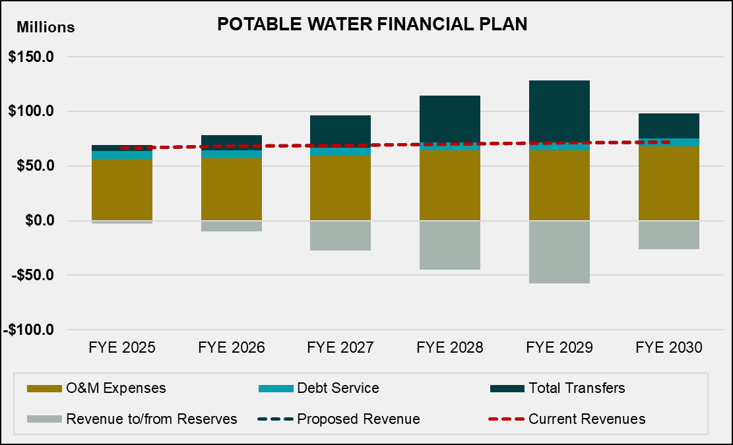

Figure 3-2 shows the projected total water fund cash balance under the status quo scenario in graphical format. Without revenue adjustments and additional debt, the cash balances (shown as blue bars) will be significantly drawn down over the study period and will be depleted in FY 2028 and continue to be negative for the planning period.

Figure 3-2: Projected Water Fund Balances (Status Quo)
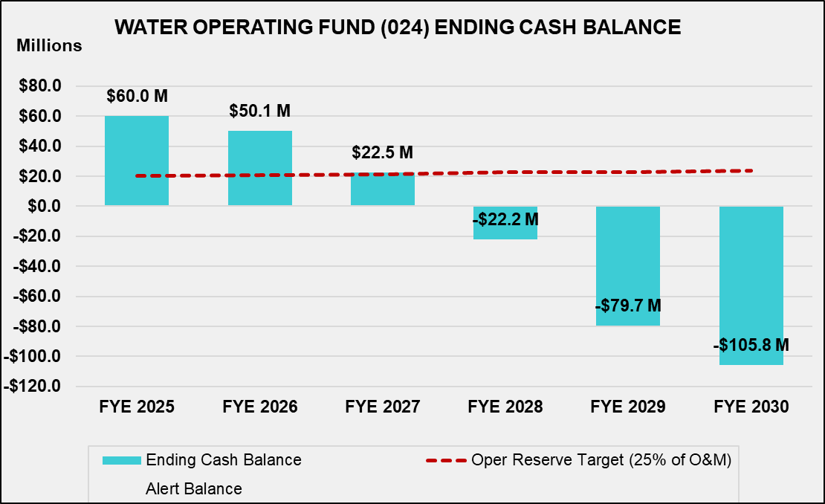

Proposed Financial Plan
The projected financial plan under the status quo scenario in Table 3-9 shows that the City’s current water rate revenues are not sufficient to sustain the water utility beginning in FY 2028.

Table 3-10 shows the proposed revenue adjustments for the study period, effective on July 1 of each fiscal year. The proposed revenue adjustments and bond issuance were developed to allow the City to fully fund the operating and capital costs of the water utility and to maintain adequate cash balances throughout the planning period.

Table 3-10: Proposed Water Revenue Adjustments and Bond Issuance
 | A | B | C | D
Line | Fiscal Year | Revenue Adjustment | Month Effective | Proposed Bonds
1 | 2026 | 5.0% | July | $0
2 | 2027 | 5.0% | July | $0
3 | 2028 | 9.0% | July | $80,000,000
4 | 2029 | 9.0% | July | $0
5 | 2030 | 9.0% | July | $0

Table 3-11 shows the projected water financial plan with the proposed revenue adjustments from

Table 3-10. The net cash flow (Line 19) is negative for three years (including the current year) of the study, which means that the City will be funding its capital costs in those years through cash reserves to minimize rate impacts.

Table 3-11: Projected Water Financial Plan (Proposed Revenue Adjustments)
 | A | B | C | D | E | F | G
Line | Financial Plan | FY 2025 | FY 2026 | FY 2027 | FY 2028 | FY 2029 | FY 2030
 | Revenues
1 | Rate Revenues | $63,552,478 | $65,184,643 | $66,203,014 | $67,241,753 | $68,301,266 | $69,381,970
2 | Revenue Adjustments | $0 | $3,259,232 | $6,785,809 | $13,564,343 | $21,165,213 | $29,679,489
3 | Other Revenues | $2,996,217 | $2,971,303 | $2,906,966 | $2,867,024 | $2,884,240 | $2,902,092
4 | Total Revenues | $66,548,695 | $71,415,178 | $75,895,789 | $83,673,119 | $92,350,719 | $101,963,551
 | O&M Expenses
5 | Water Administration | $5,602,002 | $5,946,693 | $6,220,013 | $6,456,899 | $6,651,555 | $6,852,098
6 | Pumping | $8,021,940 | $8,461,436 | $8,860,521 | $9,242,041 | $9,603,215 | $9,978,213
7 | Water Line Maintenance | $9,540,487 | $10,025,478 | $10,432,736 | $10,801,785 | $11,126,170 | $11,460,303
8 | Environmental Engr. | $2,407,553 | $2,531,674 | $2,635,388 | $2,729,025 | $2,810,896 | $2,895,223
9 | Water Purchase Costs | $25,988,958 | $24,918,011 | $26,027,714 | $29,534,191 | $28,231,283 | $30,812,072
10 | Water Resources | $2,068,197 | $2,194,422 | $2,294,591 | $2,381,455 | $2,452,898 | $2,526,485
11 | Customer Services | $2,969,793 | $3,081,913 | $3,186,690 | $3,288,758 | $3,387,420 | $3,489,043
12 | Total | $56,598,930 | $57,159,628 | $59,657,652 | $64,434,153 | $64,263,437 | $68,013,437
 | Debt Service and Capital
13 | Existing Debt Service | $7,033,031 | $7,217,959 | $7,211,299 | $7,211,274 | $7,207,388 | $7,203,497
14 | Proposed Debt Service | $0 | $0 | $0 | $5,204,115 | $5,204,115 | $5,204,115
15 | Rate Funded Capital | $2,599,706 | $9,925,431 | $24,852,057 | $0 | $9,900,518 | $15,412,967
16 | Transfer to Recycled Water | $3,141,560 | $3,543,035 | $3,507,698 | $2,847,630 | $2,372,924 | $1,927,719
17 | Total | $12,774,297 | $20,686,425 | $35,571,054 | $15,263,019 | $24,684,945 | $29,748,297
18 | Total Revenue Required | $69,373,227 | $77,846,053 | $95,228,706 | $79,697,172 | $88,948,382 | $97,761,735
19 | Net Cash Flow | ($2,824,532) | ($6,430,874) | ($19,332,917) | $3,975,947 | $3,402,337 | $4,201,816
20 | Net Operating Revenue | $9,949,765 | $14,255,551 | $16,238,137 | $19,238,966 | $28,087,282 | $33,950,113
21 | Calculated Debt Coverage | 1.41 | 1.98 | 2.25 | 1.55 | 2.26 | 2.74
22 | Required Debt Coverage | 1.25 | 1.25 | 1.25 | 1.25 | 1.25 | 1.25
23 | Beginning Fund Balance | $62,837,402 | $60,012,870 | $53,581,996 | $34,249,079 | $38,225,026 | $41,627,363
24 | Ending Fund Balance | $60,012,870 | $53,581,996 | $34,249,079 | $38,225,026 | $41,627,363 | $45,829,178
25 | Reserve Target | $13,955,900 | $14,094,155 | $14,710,106 | $15,887,873 | $15,845,779 | $16,770,437

Figure 3-3 shows the proposed water capital financing plan in graphical format, based on the capital financial plan shown in Table 3-8.

Figure 3-3: Proposed Water Capital Financing Plan
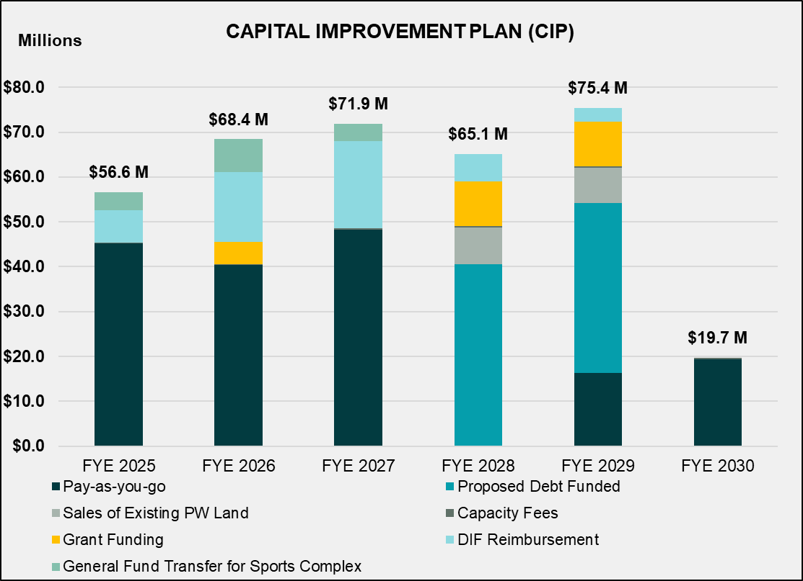

Figure 3-4 shows the proposed financial plan in graphical format with the revenue adjustments in

Table 3-10. The proposed revenues, shown as the dotted dark blue line, allow the City to fund its operating and capital costs for the study period. As shown in Figure 3-4, the City will use reserves for the first three years of the study.

Figure 3-4: Projected Water Financial Plan (Proposed Revenue Adjustments)
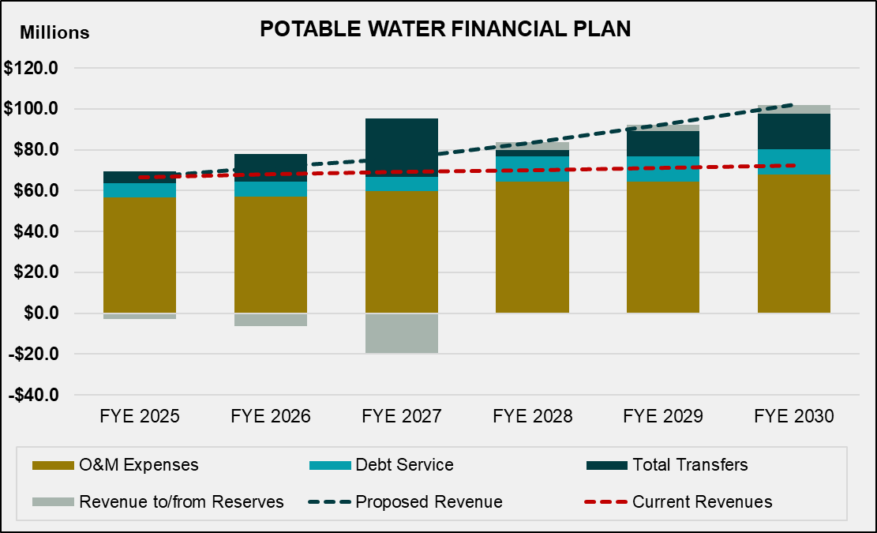

Figure 3-5 shows the projected water fund balances with the proposed revenue adjustments in

Table 3-10. The light blue bars represent the unrestricted cash balance available to finance operating expenses and capital projects. The water operating fund has an adequate ending cash balance in each fiscal year throughout the forecast period.

Figure 3-5: Projected Water Fund Balances (Proposed Revenue Adjustments)

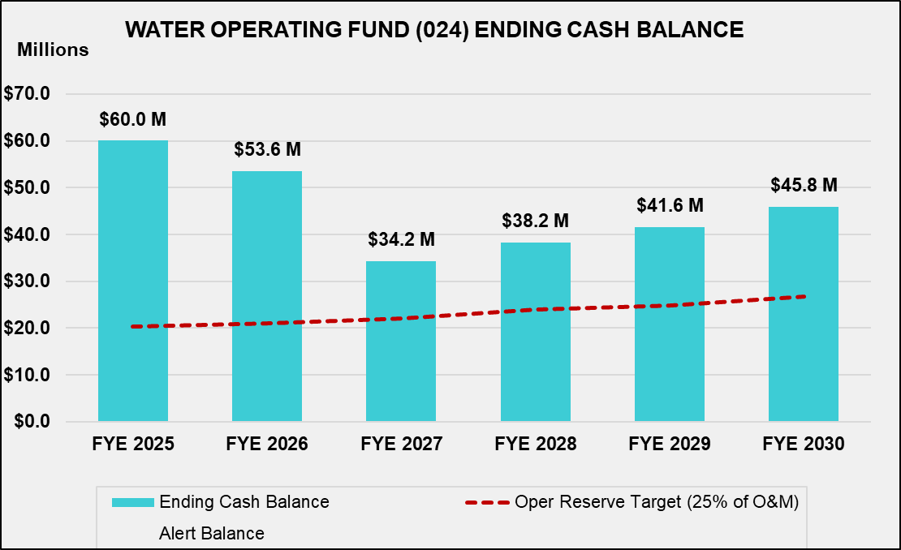

Water Cost of Service

A cost-of-service analysis distributes a utility’s revenue requirement (yearly revenues needed from rates) to each customer class by allocating the City’s revenue requirement to the cost causation components, which include:

- Water supply
- Base delivery (average) costs
- Peaking costs (maximum day and maximum hour)
- Meter service
- Billing and customer service
- Fire protection
- General and administrative costs (legal, office supplies, minor equipment purchases, miscellaneous materials and supplies, training, uniforms, etc.)

Peaking costs are further divided into maximum day and maximum hour demand. The maximum day demand is the maximum amount of water used on a single day in a year. The maximum hour demand is the maximum hour use on the maximum use day. Both maximum day and maximum hour peaking demand are used to calculate peaking unit rates to distribute costs to customer classes. Peaking costs are allocated in proportion to how the different customer classes use water during peak day and hour demands. Different facilities, such as distribution and storage facilities, are designed to meet the peaking demands of customers. Therefore, extra capacity costs include the O&M and capital costs associated with meeting peak customer demand. This method is consistent with the AWWA M1 Manual and is widely used in the water industry to perform cost-of-service analyses.

Revenue Requirement Determination
Table 4-1 shows the test year revenue requirement derivation, which results in the total revenue required from water rates (Line 19). The revenue requirement is comprised of the Operating (Column B, Line 19) and Capital (Column C, Line 19) revenue requirements, which are allocated to the cost causation components based on the proportion of O&M expense and capital asset functions, respectively. The adjustment for cash balance (Line 17) is equal to the net cash flow for FY 2026 (Table 3-11, Column C, Line 19).

Table 4-1: FY 2026 Potable Revenue Requirements
 | A |  |  | B | C | D
Line | Potable Water FY 2024 Requirements |  |  | Operating | Capital | Total
 | Revenue Requirements
1 | O&M Expenses
2 | Water Administration |  |  | $5,946,693 |  | $5,946,693
3 | Pumping |  |  | $8,461,436 |  | $8,461,436
4 | Water Line Maintenance |  |  | $10,025,478 |  | $10,025,478
5 | Environmental Engineering |  |  | $2,531,674 |  | $2,531,674
6 | Water Purchase Costs |  |  | $24,918,011 |  | $24,918,011
7 | Water Resources |  |  | $2,194,422 |  | $2,194,422
8 | Customer Services |  |  | $3,081,913 |  | $3,081,913
9 | Existing Debt Service |  |  |  | $7,217,959 | $7,217,959
10 | Proposed Debt Service |  |  |  | $0 | $0
11 | Transfers
 | Rate Funded Capital Projects |  |  |  | $9,925,431 | $9,925,431
12 | Recycled Water |  |  | $3,543,035 |  | $3,543,035
13 | Total Revenue Requirements |  |  | $60,702,663 | $17,143,390 | $77,846,053
 | Less: Revenue Offsets
14 | Miscellaneous Revenues |  |  | $2,679,189 |  | $2,679,189
15 | Interest Income |  |  | $292,114 |  | $292,114
16 | Total Revenue Offsets |  |  | $2,971,303 | $0 | $2,971,303
 | Less: Adjustments
17 | Adjustment for Cash Balance |  |  |  | $6,430,874 | $6,430,874
18 | Total Adjustments |  |  | $0 | $6,430,874 | $6,430,874
19 | Revenue Requirement from Rates |  |  | $57,731,360 | $10,712,515 | $68,443,875

Allocation of Expenses to Cost Causation Components
In a cost-of-service analysis, the City’s expenses are allocated to the cost causation components. To do so, it is necessary to identify the system-wide peaking factors shown in Table 4-2. The system-wide peaking factors (Column B) are used to derive the cost component allocation bases/percentages (Columns C through E). These peaking factors are from Section 4 of the City’s Water Master Plan. Maximum day peaking factors are observed, and maximum hour peaking factors are estimated as stated on page 4-8 of the plan. As a water purveyor, the City must construct its water system with sufficient capacity to serve peak demands from high water users. This means, for example, that the City must build, operate and maintain sufficient system storage to serve peak demand. Peaking factors help to correlate the specific costs associated with accommodating peak demand, with the drivers of those costs. Water systems are designed for average day (Average Day), maximum day (Max Day) and maximum hour (Max Hour) peaks. Average Day, Max Day, and Average Day ratio calculations are calculated using the guideline provided in AWWA’s Principles of Water Rates, Fees, and Charges, Manual M1. Average day use represents the average annual use expressed as a daily demand. The Max Day peaking factor is expressed as a percentage or multiple of Average Day demand and represents the maximum demand on any day of the year. Typically, because of irrigation demands, the Max Day demand will occur in summer. Reservoirs and transmission lines are designed for Max Day demand. Max Hour demand is the peak demand of one hour on the Max Day, expressed as a percentage or multiple of the Average Day demand. Distribution lines are designed for Max Hour plus fire flow demand.

The significance of peaking factors and cost allocation is best explained by looking at the City’s infrastructure investments. The extra capacity costs to build and maintain infrastructure to serve Max Day and Hour demands are significantly higher than the costs associated with Average Day demand. Larger pipelines, storage tanks, and pumps used to serve peak demands are more expensive and add to the City’s costs to provide water service.

To understand the interpretation of the percentages, we must first establish the base use as the average daily demand during the year, which is assigned an allocation basis of 100 percent. If the base allocation basis is used to allocate an expense, it means that the costs associated with that expense are incurred to meet average daily demand (Base) related costs.

Expenses that are allocated to the cost causation components using the maximum day basis are those attributed to ensuring the water system can accommodate the maximum expected daily demand. The Max Day allocation (Line 2) attributes 64.5 percent (1.00/1.55) of the demand (and therefore costs) to Base use (average daily demand) and the remainder to maximum day use (peaking). Expenses allocated using the Maximum Hour base (Line 3) assume 50.5 percent (1.00/1.98) of costs are due to Base demands, 27.8 percent due to Max Day ((1.55-1.00)/1.98) and the remaining 21.7 percent are due to Max Hour costs.

Table 4-2: System Peaking Factors, Conversions, and Cost Component Allocations
 | A | B | C | D | E | F
Line | Description | Factor | Base Delivery | Max Day | Max Hour | Total
1 | Base | 1.00 | 100% | 0% | 0% | 100%
2 | Max Day | 1.55 | 64.5% | 35.5% | 0% | 100%
3 | Max Hour | 1.98 | 50.5% | 27.8% | 21.7% | 100%

The allocation basis for each expense is chosen based on the type of cost for each line item and the proportion of those costs associated with each cost causation component (Base or average demand, Max Day, Max Hour, General, etc.). The allocation is based on the design basis of the different components of the water system. For example, pumps on wells are often designed to meet Max Day demands and costs are allocated 64.5 percent to Base and 35.5 percent to Max Day as shown in Table 4-3.

Actual O&M expenses are then allocated to the cost components, as shown in Table 4-4. The O&M allocation percentages (Line 11) are then used to allocate the Operating revenue requirement (Table 4-1, Column B, Line 19) in a later section.

Assets are allocated in a similar process, as shown in Table 4-5 and Table 4-6. The capital allocation percentages (Table 4-6, Line 11) are then used to allocate the Capital revenue requirement (Table 4-1, Column C, Line 19) in a later section. Annual capital project costs are not used to allocate the Capital revenue requirement because they tend to vary from year to year, and so Capital assets are often used to allocate the Capital revenue requirement to reduce rate fluctuations. Assets represent the utility’s long-term investments in its capital infrastructure and do not fluctuate as much each year. The asset list as of June 30, 2022 was provided by the City.

Table 4-3: Potable O&M Allocation Factors
 | A | B | C | D | E | F | G | H | I | J
Line | Potable O&M Allocation | Supply | Base Delivery | Max Day | Max Hour | Meters | Customer | Fire | General | Total
1 | Supply | 100% |  |  |  |  |  |  |  | 100%
2 | Pumping |  | 64.5% | 35.5% |  |  |  |  |  | 100%
3 | Treatment |  | 100% |  |  |  |  |  |  | 100%
4 | Storage |  | 64.5% | 35.5% |  |  |  |  |  | 100%
5 | T&D |  | 50.5% | 27.8% | 21.7% |  |  |  |  | 100%
6 | Meters |  |  |  |  | 100% |  |  |  | 100%
7 | Customer Service |  |  |  |  |  | 100% |  |  | 100%
8 | Fire Protection |  |  |  |  |  |  | 100% |  | 100%
9 | General |  |  |  |  |  |  |  | 100% | 100%
Note: T&D - Transmission and Distribution
Table 4-4: Potable O&M Allocations
 | A | B | C | D | E | F | G | H | I | J
Line | Potable O&M Cost | Supply | Base Delivery | Max Day | Max Hour | Meters | Customer | Fire | General | Total
1 | Supply | $25,341,083 | $0 | $0 | $0 | $0 | $0 | $0 | $0 | $25,341,083
2 | Pumping | $0 | $3,548,344 | $1,951,589 | $0 | $0 | $0 | $0 | $0 | $5,499,934
3 | Treatment | $0 | $2,325,206 | $0 | $0 | $0 | $0 | $0 | $0 | $2,325,206
4 | Storage | $0 | $545,899 | $300,245 | $0 | $0 | $0 | $0 | $0 | $846,144
5 | T&D | $0 | $3,490,654 | $1,919,860 | $1,500,981 | $0 | $0 | $0 | $0 | $6,911,495
6 | Meters | $0 | $0 | $0 | $0 | $3,007,644 | $0 | $0 | $0 | $3,007,644
7 | Customer Service | $0 | $0 | $0 | $0 | $0 | $4,585,735 | $0 | $0 | $4,585,735
8 | Fire Protection | $0 | $0 | $0 | $0 | $0 | $0 | $501,274 | $0 | $501,274
9 | General | $0 | $0 | $0 | $0 | $0 | $0 | $0 | $8,141,115 | $8,141,115
10 | Total O&M Expenses | $25,341,083 | $9,910,103 | $4,171,694 | $1,500,981 | $3,007,644 | $4,585,735 | $501,274 | $8,141,115 | $57,159,628
11 | O&M Allocation | 44.3% | 17.3% | 7.3% | 2.6% | 5.3% | 8.0% | 0.9% | 14.2% | 100.0%

Table 4-5: Potable Asset Allocation Factors
 | A | B | C | D | E | F | G | H | I | J
Line | Potable O&M Allocation | Supply | Base Delivery | Max Day | Max Hour | Meters | Customer | Fire | General | Total
1 | Supply | 100% |  |  |  |  |  |  |  | 100%
2 | Pumping |  | 64.5% | 35.5% |  |  |  |  |  | 100%
3 | Treatment |  | 100% |  |  |  |  |  |  | 100%
4 | Storage |  | 64.5% | 35.5% |  |  |  |  |  | 100%
5 | T&D |  | 50.5% | 27.8% | 21.7% |  |  |  |  | 100%
6 | Meters |  |  |  |  | 100% |  |  |  | 100%
7 | Customer Service |  |  |  |  |  | 100% |  |  | 100%
8 | Fire Protection |  |  |  |  |  |  | 100% |  | 100%
9 | General |  |  |  |  |  |  |  | 100% | 100%

Table 4-6: Potable Asset Allocations
 | A | B | C | D | E | F | G | H | I | J
Line | Potable Assets | Supply | Base Delivery | Max Day | Max Hour | Fire | Meter | Customer | General | Total
1 | Supply | $57,940,320 | $0 | $0 | $0 | $0 | $0 | $0 | $0 | $57,940,320
2 | Pumping | $0 | $2,893,928 | $1,591,660 | $0 | $0 | $0 | $0 | $0 | $4,485,588
3 | Treatment | $0 | $24,724,396 | $0 | $0 | $0 | $0 | $0 | $0 | $24,724,396
4 | Storage | $0 | $46,590,131 | $25,624,572 | $0 | $0 | $0 | $0 | $0 | $72,214,702
5 | T&D | $0 | $179,900,226 | $98,945,124 | $77,357,097 | $0 | $0 | $0 | $0 | $356,202,447
6 | Meters | $0 | $0 | $0 | $0 | $19,031,079 | $0 | $0 | $0 | $19,031,079
7 | Customer Service | $0 | $0 | $0 | $0 | $0 | $1,137,294 | $0 | $0 | $1,137,294
8 | Fire Protection | $0 | $0 | $0 | $0 | $0 | $0 | $15,092,890 | $0 | $15,092,890
9 | General | $0 | $0 | $0 | $0 | $0 | $0 | $0 | $8,115,007 | $8,115,007
10 | TOTAL ASSETS | $57,940,320 | $254,108,680 | $126,161,356 | $77,357,097 | $19,031,079 | $1,137,294 | $15,092,890 | $8,115,007 | $558,943,723
11 | Capital Allocation | 10.4% | 45.5% | 22.6% | 13.8% | 3.4% | 0.2% | 2.7% | 1.5% | 100.0%

Units of Service
Once all expenses have been allocated to the appropriate cost components, the next step is to determine the units of service from which the costs will be recovered. The units are the number of customers, equivalent meter units (EMUs), annual water use, and extra capacity units. Private fire connections and city hydrants are also used in the calculation of private fire charges.

Customer and Meter Equivalents
Table 4-7 summarizes customer and equivalent meter units. Meter counts (Columns D, F, and H) can also be found in Table 3-1. EMUs represent the potential demand that meters can place on the system. The AWWA M1 Manual provides data about the potential demand that each standard meter size can place on the system. For this study, the base meter is the 5/8-inch meter, which is the most common meter size. The AWWA ratio (Column C) is calculated by dividing the capacity in gallons per minute (gpm) (Column B) for each meter size by the capacity of a 5/8-inch meter (Column B, Line 1). EMUs for each class are derived by multiplying the AWWA ratio (Column C) by the number of accounts at a given meter size. The numbers shown in the tables of this section are rounded. Therefore, hand calculations based on the displayed numbers, such as summing or multiplying, may not equal the exact results shown.

Table 4-7: Customer and Equivalent Meter Units
 | A | B | C | D | E | F | G | H | I
Line | Meter Size | Capacity (gpm) | AWWA Ratio | SFR Meters | SFR EMUs | Non-SFR Meters | Non-SFR EMUs | All Meters | EMUs
1 | 5/8" | 20 | 1.00 | 25,135 | 25,135 | 1,468 | 1,468 | 26,603 | 26,603
2 | 3/4" | 30 | 1.50 | 5,512 | 8,268 | 25 | 38 | 5,538 | 8,306
3 | 1" | 50 | 2.50 | 1,183 | 2,957 | 1,234 | 3,084 | 2,417 | 6,042
4 | 1 1/2" | 100 | 5.00 | 34 | 172 | 1,211 | 6,056 | 1,245 | 6,227
5 | 2" | 160 | 8.00 | 10 | 83 | 2,091 | 16,729 | 2,102 | 16,812
6 | 3" | 350 | 17.50 | 0 | 0 | 161 | 2,815 | 161 | 2,815
7 | 4" | 630 | 31.50 | 0 | 0 | 91 | 2,879 | 91 | 2,879
8 | 6" | 1,300 | 65.00 | 0 | 0 | 43 | 2,827 | 43 | 2,827
9 | 8" | 2,400 | 120.00 | 0 | 0 | 59 | 7,107 | 59 | 7,107
10 | 10" | 3,800 | 190.00 | 0 | 0 | 2 | 395 | 2 | 395
11 | Total |  |  | 31,875 | 36,615 | 6,387 | 43,398 | 38,261 | 80,014

Equivalent fire accounts are treated similarly, using the Hazen Williams equation for pipe flow, demonstrated in Table 4-8. The fire ratios (Column B) are applied to the number of private fire connections to determine the number of 6-inch fire line equivalents; the same is applied to fire hydrants (Column E), which assumes a 6-inch diameter line. The proportion of equivalent fire lines allocated to private and public fire protection (Line 10) are used in Table 4-11 to calculate the cost of providing private fire protection service.

Table 4-8: Equivalent Fire Line Units
 | A | B | C | D | E | F
Line | Line Size | Fire Ratio | Lines | Eq. Lines | Hydrants | Eq. Hydrants
1 | 2" | 0.06 | 10 | 1
2 | 4" | 0.34 | 204 | 70
3 | 6" | 1.00 | 439 | 439
4 | 8" | 2.13 | 865 | 1843
5 | 10" | 3.83 | 372 | 1426
6 | 12" | 6.19 | 11 | 68
7 | 16" | 13.19 | 0 | 0
8 | 6" | 1.00 |  |  | 7,886 | 7,886
9 | Total |  | 1,901 | 3,847 | 7,886 | 7,886
10 | % of Equiv. Lines |  |  | 32.8% |  | 67.2%

Water Usage and Peaking
The service units also include annual water use and peaking units. Table 4-9 shows the peaking factors (Columns C and D) for each customer class and tier. Raftelis received detailed billing data from City staff, which was then analyzed to determine each one. The Single Family Residential (SFR) tier definitions (Column B) are discussed in detail in a later section.

Table 4-9: Class Peaking Factors
 | A | B | C | D
Line | Customer Class | Proposed Tiers (hcf) | Max Month | Max Day
 | SFR
1 | Tier 1 | 10 | 1.08 | 1.18
2 | Tier 2 | 18 | 1.48 | 1.62
3 | Tier 3 | 18+ | 1.90 | 2.07
 | Non-SFR
4 | Multi-Family |  | 1.14 | 1.24
5 | Commercial |  | 1.14 | 1.24
6 | Industrial |  | 1.14 | 1.24
7 | Government |  | 1.57 | 1.71
8 | City |  | 1.18 | 1.29
9 | Irrigation |  | 1.57 | 1.71

Table 4-10 shows the calculation of extra capacity units for each class. Annual usage (Column C) is the total amount of water each class is forecasted to use in the test year, which is also shown in Table 3-1. Average day (Column D) is equal to annual use divided by 365 days.

The Max Day peaking factor (Column E) was derived in Table 4-9. It represents the relationship between a forecasted average month and the single highest month of use (maximum month) for a given class. The Max Day peaking factor is multiplied by the average day use to determine the Max Day total capacity (Column F). The extra capacity required to serve water under Max Day conditions (Column G) is the difference between the Max Day total capacity and the average day use. These extra capacity units are used to distribute peaking costs between the classes.

The Max Hour peaking factor (Column H) is calculated by multiplying the Max Day factor by the ratio of the system Max Day and Max Hour factors in Table 4-2.The same steps as described above are applied to calculate Max Hour total capacity (Column I). The extra capacity for Max Hour use is calculated by subtracting Max Day total capacity from Max Hour total capacity.

EMUs and accounts (Columns K and L) are obtained from Table 4-7.

Cost Distributions to the Cost Causation components
Table 4-11 summarizes the results of the cost allocation to the cost causation components and the final unit costs for each cost causation component. The operating revenue requirement (Column J, Line 1) is from Table 4-1 and is allocated based on the operating allocation percentages from Table 4-4. The capital revenue requirement (Column J, Line 2) is also from Table 4-1 and is allocated based on the capital allocation percentages from Table 4-6. Note that the total revenue requirement (Table 4-11, Column J, Line 3) is equal to the total revenue required from rates (Table 4-1, Column D, Line 19).

General costs (Column I) are reallocated back to all other components based on the proportion of costs within each cost component in the total cost of service (Line 3). Public fire protection costs (Line 5) are reallocated based on the percentage of equivalent fire lines for public fire hydrants (Table 4-8, Line 10); these costs are recovered from rate payers in their fixed meter charge. Finally, the City chooses to reallocate 65 percent of extra capacity and 35 percent of base capacity peaking costs to the equivalent meter basis in order to reach revenue stability goals. Peaking costs can be recovered in proportion to meter size. Total adjusted costs (Line 8), fully allocated to the appropriate cost causation components, are used to determine the final unit costs.

The unit costs (Line 11) are the result of dividing the adjusted cost of service (Line 8) for each cost causation component by the units of service (Line 9), which were summarized in Table 4-10. Unit costs on Line 11 for meters, customers, and fire protection are monthly costs.

Table 4-12 presents the results of the cost-of-service analysis. Using the unit costs calculated in Table 4-11 and the detailed units of service in Table 4-10, the costs are distributed to each customer class. Supply and Base Delivery are distributed to each customer class and tier based on annual water use (Table 4-10, Column C). Max Day and Max Hour costs are distributed based on extra capacity units for each component (Table 4-10, Columns G and J, respectively). Fire costs are distributed based on equivalent fire lines (Table 4-10, Column M, Line 5). Meter costs are distributed based on EMUs (Table 4-10, Column K). Finally, Customer costs are distributed based on the number of bills (Table 4-10, Column L multiplied by 12).

For example, the Supply costs for SFR Tier 1 (Column B, Line 2) are calculated using the following formula:

Supply unit cost [Table 4-11, Column B, Line 11] x SFR Tier 1 annual use [Table 4-10, Column C, Line 1]

Table 4-10: Units of Service
 | A | B | C | D | E | F | G | H | I | J | K | L | M
Line | Customer Class | Monthly Tiers (hcf) | Annual Use (hcf) | Average Daily Use | MD Capacity Factor | MD Total Capacity | MD Extra Capacity | MH Capacity Factor | MH Total Capacity | MH Extra Capacity | EMUs | Accounts | Eq. Lines
 | SFR |  |  |  |  |  |  |  |  |  | 36,615 | 31,875
1 | Tier 1 | 10 | 3,212,086 | 8,800 | 1.18 | 10,374 | 1,574 | 1.51 | 13,252 | 2,878
2 | Tier 2 | 18 | 1,131,759 | 3,101 | 1.62 | 5,009 | 1,908 | 2.06 | 6,399 | 1,390
3 | Tier 3 | 18+ | 889,896 | 2,438 | 2.07 | 5,056 | 2,618 | 2.65 | 6,459 | 1,403
4 | Non-SFR |  | 7,387,123 | 20,239 | 1.39 | 28,109 | 7,871 | 1.77 | 35,907 | 7,798 | 43,398 | 6,387
5 | Private Fire Service |  |  |  |  |  |  |  |  |  |  | 1,901 | 3,847
6 | Total |  | 12,620,864 |  |  | 48,549 | 13,972 |  | 62,018 | 13,469 | 80,014 | 40,642 | 3,847

Table 4-11: Unit Cost of Service
 | A | B | C | D | E | F | G | H | I | J
Line | Cost of Service | Supply | Base Delivery | Max Day | Max Hour | Meters | Customer | Fire | General | Total
1 | Operating Expenses | $25,594,554 | $10,009,228 | $4,213,420 | $1,515,995 | $3,037,727 | $4,631,603 | $506,288 | $8,222,545 | $57,731,360
2 | Capital Expenses | $1,110,463 | $4,870,156 | $2,417,963 | $1,482,598 | $364,743 | $21,797 | $289,265 | $155,529 | $10,712,515
3 | Total Cost of Service | $26,705,017 | $14,879,384 | $6,631,384 | $2,998,593 | $3,402,470 | $4,653,400 | $795,553 | $8,378,075 | $68,443,875
4 | Allocation of General Cost | $3,724,859 | $2,075,400 | $924,956 | $418,249 | $474,582 | $649,064 | $110,965 | -$8,378,075 | $0
5 | Allocation of Public Fire Cost |  |  | ($427,263) | ($741,070) | $1,168,333 |  |  |  | $0
6 | Allocation of Private Fire Cost |  |  | ($208,422) | ($361,498) |  |  | $375,401 |  | $0
7 | Allocation of Peaking Cost to Meter |  | ($5,934,174) | ($4,911,621) | ($2,220,947) | $13,066,742 |  |  |  | $0
8 | Total Adjusted Cost of Service | $30,429,876 | $11,020,610 | $2,009,034 | $93,326 | $18,112,127 | $5,302,464 | $1,476,438 | $0 | $68,443,875
9 | Unit of Service | 12,620,864 | 12,620,864 | 13,972 | 13,469 | 80,014 | 481,947 | 3,847
10 | Unit | hcf | hcf | hcf/day | hcf/day | equiv. meter | annual bills | equiv. lines
11 | Unit Cost | $2.41 | $0.87 | $143.79 | $6.93 | $18.86 | $11.00 | $31.98

Table 4-12: Class Cost of Service
 | A | B | C | D | E | F | G | H | I
Line | Potable Cost of Service by Class | Supply | Base Delivery | Max Day | Max Hour | Meters | Customer | Fire | Total
1 | SFR |  |  |  |  | $8,288,339 | $4,208,296 |  | $12,628,563
2 | Tier 1 | $7,744,587 | $2,804,812 | $226,350 | $19,943 |  |  |  | $10,228,809
3 | Tier 2 | $2,728,757 | $988,258 | $274,426 | $9,629 |  |  |  | $5,023,138
4 | Tier 3 | $2,145,609 | $777,063 | $376,504 | $9,720 |  |  |  | $1,734,038
5 | Non-SFR | $17,810,923 | $6,450,477 | $1,131,753 | $54,035 | $9,823,789 | $843,187 |  | $37,186,421
6 | Private Fire Service |  |  |  |  |  | $250,982 | $1,476,438 | $1,626,165
7 | Total | $30,429,876 | $11,020,610 | $2,009,034 | $93,326 | $18,112,127 | $5,302,464 | $1,476,438 | $68,443,875

Water Rate Design

While the cost-of-service analysis determines how much revenue should be recovered from each customer class, the rate design process determines how and on what basis. Costs are allocated to the fixed and volume charges of each class in order to recover costs in a manner that is equitable and meets the City’s goals.

Proposed Monthly Service Charge
The monthly service charge recovers two types of costs:

- costs associated with maintaining and servicing meters and
- capacity (also known as peaking) costs.

Both costs increase as the meter size increases and are proportional to the AWWA hydraulic capacity ratios shown in Table 4-7. The AWWA capacity ratios, which are a function of a meter’s safe maximum flow rate, are used to increase the meter service component for larger capacity meters which impose a greater demand on the system and require larger systems and therefore are responsible for higher costs. This assumes that the potential capacity (peaking) demand is proportional to the potential flow through each meter size as established by the AWWA capacity ratios. The meter service component for a 5/8-inch meter (Table 4-11, Column F, Line 11) minus the unit cost for watermaster assessment, IEUA and the Metropolitan Water District of Southern California (MWD) is multiplied by the AWWA ratio for each meter size (Column B) to determine the Meter cost by size (Column C). The meter cost causation component includes fixed charges for watermaster assessment, IEUA and MWD. Those costs spread on all the EMUs results in the 5/8” equivalent unit rates of $2.41, $1.27 and $0.66, respectively, and are shown separately in Table 5-1 (Columns F, G, and H).

The Customer component ( Table 4-11, Column G, Line 11) recovers costs associated with meter reading, customer billing and collection, as well as answering customer calls. These costs are the same for all meter sizes as it costs the same to bill a small meter as it does a larger meter. Customer costs (Column D) are the same for all meter sizes.

Table 5-1: Monthly Fixed Charge Derivation by Meter Size
 | A | B | C | D | E | F | G | H | I
Line | Meter Size | AWWA Ratio | Meter | Customer | Proposed City Charge | Watermaster Assessment | IEUA MEU | MWD RTS | Proposed Total Charge
1 | 5/8" | 1.00 | $14.53 | $11.00 | $25.53 | $2.41 | $1.27 | $0.66 | $29.87
2 | 3/4" | 1.50 | $21.79 | $11.00 | $32.79 | $3.61 | $1.91 | $0.99 | $39.30
3 | 1" | 2.50 | $36.31 | $11.00 | $47.31 | $6.01 | $3.19 | $1.65 | $58.16
4 | 1 1/2" | 5.00 | $72.63 | $11.00 | $83.63 | $12.03 | $6.37 | $3.29 | $105.32
5 | 2" | 8.00 | $116.20 | $11.00 | $127.20 | $19.25 | $10.19 | $5.27 | $161.91
6 | 3" | 17.50 | $254.19 | $11.00 | $265.19 | $42.10 | $22.30 | $11.52 | $341.11
7 | 4" | 31.50 | $457.54 | $11.00 | $468.54 | $75.78 | $40.14 | $20.74 | $605.20
8 | 6" | 65.00 | $944.13 | $11.00 | $955.13 | $156.38 | $82.82 | $42.80 | $1,237.13
9 | 8" | 120.00 | $1,743.00 | $11.00 | $1,754.01 | $288.70 | $152.90 | $79.02 | $2,274.63
10 | 10" | 190.00 | $2,759.76 | $11.00 | $2,770.76 | $457.11 | $242.09 | $125.11 | $3,595.08
Note: E = C + D and I = E + F + G + H

Proposed Monthly Private Fire Protection Charge
Table 5-2 shows the derivation of the monthly private fire charge (Column E). The fire cost in Column C is calculated for each line size by multiplying the unit cost of fire protection (Table 4-11, Column H, Line 11) by the flow ratios in Column B. The proposed private fire charge is calculated by adding the scaled fire cost (Column C) to the customer billing charge (Column D). The proposed private fire charges are proportional to the potential flow through each private fire connection.

Table 5-2: Monthly Private Fire Charge Derivation by Meter Size
 | A | B | C | D | E
Line | Line Size | Flow Ratio | Fire | Customer | Proposed Charge
1 | 2" | 0.06 | $1.78 | $11.00 | $12.78
2 | 4" | 0.34 | $11.01 | $11.00 | $22.01
3 | 6" | 1.00 | $31.98 | $11.00 | $42.99
4 | 8" | 2.13 | $68.16 | $11.00 | $79.16
5 | 10" | 3.83 | $122.57 | $11.00 | $133.57
6 | 12" | 6.19 | $197.99 | $11.00 | $208.99
7 | 16" | 13.19 | $421.92 | $11.00 | $432.92

Volumetric Rates

Customer Classes
Raftelis does not recommend changes to volumetric rate structures. Single Family class customers are more homogenous and conservation rate structures with inclining tiers are common for this class based on customer usage patterns. Specifically, Single Family customers are more likely to have predictable peaking patterns based on seasonality: water use during the summer months tends to peak more due to increased irrigation needs. The City incurs costs specific to accommodating such peak demand with infrastructure sized to provide capacity. To ensure that customers with higher use due to peaking cover the costs proportionally, tiered rates are proposed for Single Family Residential customers. The remaining customers vary significantly in size and use and generally are subject to uniform rates.

Tier Definitions
Table 5-3 shows the current tier definitions for customer classes.

Table 5-3: Current Volumetric Tiers
 | A | B
Line | Tier | Current
 | SFR
1 | Tier 1 | 1-10
2 | Tier 2 | 11-18
3 | Tier 3 | Above 18
 | Non-SFR
4 | All Non-SFR | Uniform

A uniform rate for all other customer classes is appropriate because of smaller peaking requirements. Commercial customers tend to be much less homogenous and their individual water needs vary significantly. Such customers do not place peak demand on the system in the same way as single-family residential customers. For example, a large commercial customer, such as a hospital, may use large volumes of water consistently. It may be inequitable to charge most of its use at Tier 3 rates; therefore uniform rates are common for industrial customers.

Commodity Cost Component Definitions
The commodity rates for each class and tier are derived by summing the unit rates ($/hcf) for:

- Water Supply
- Base Delivery
- Peaking

Water Supply costs are costs associated with purchasing water from each of the four sources discussed in Section 3. When determining unit supply costs for each class and tier, Raftelis and City staff chose to allocate the lowest cost purchased water to the lower tiers because the City would not have to purchase more expensive water if all customers used water like Tier 1 customers. All residential users will benefit from the most affordable water used by the City and larger residential users will pay their proportionate share of the more expensive sources. Table 5-4 shows the ranking of the water cost per hcf from each supplier. The demand from each source in AF (Line 1) corresponds to Table 3-3 before accounting for water loss.

Table 5-4: Water Supply Unit Costs
 | A | B | C | D | E | F
Line | Water Source | San Antonio | Groundwater | CDA | WFA | Total
1 | Water Demand (AF) | 576 | 14,446 | 8,192 | 5,760 | 28,974
2 | Water Demand (hcf) | 250,906 | 6,292,606 | 3,568,296 | 2,509,056 | 12,620,864
3 | Total Cost | $251,651 | $7,695,299 | $12,040,054 | $10,442,872 | $30,429,876
4 | Unit Cost per hcf | $1.00 | $1.22 | $3.37 | $4.16 | $2.41

The total supply available from each source is allocated to SFR and Non-SFR customers in Table 5-5 proportionally according to the water used (Lines 1-2). Water is allocated to each SFR tier in order of lowest to highest cost (Lines 3-5). For example, Tier 1 (Line 3) receives the entire SFR allocation of San Antonio water, the entire allocation of groundwater, and a portion of CDA water sufficient to meet SFR needs. The remainder of CDA water is allocated to Tier 2 (Line 4). The unit cost (Column G) is the result of multiplying the volumes from each source by the unit cost for each source divided by the total volume for each line (Table 5-4, Line 4). It represents a weighted supply cost of all water sources used by the class or tier.

Table 5-5: Water Supply Unit Rates
 | A | B | C | D | E | F | G
Line | Class | San Antonio | Groundwater | CDA | WFA | Total | Unit Cost
1 | SFR | 104,048 | 2,609,478 | 1,479,735 | 1,040,479 | 5,233,741 | $2.41
2 | Non-SFR | 146,858 | 3,683,128 | 2,088,561 | 1,468,577 | 7,387,123 | $2.41
 | SFR
3 | Tier 1 | 104,048 | 2,609,478 | 498,560 | 0 | 3,212,086 | $1.55
4 | Tier 2 | 0 | 0 | 981,176 | 150,583 | 1,131,759 | $3.48
5 | Tier 3 | 0 | 0 | 0 | 889,896 | 889,896 | $4.16
6 | Non-SFR | 146,858 | 3,683,128 | 2,088,561 | 1,468,577 | 7,387,123 | $2.41
7 | Total | 250,906 | 6,292,606 | 3,568,296 | 2,509,056 | 12,620,864 | $2.41

Base delivery costs are the operating and capital costs associated with delivering water to all customers through the distribution system (pipelines and storage reservoirs) at a constant average rate of use – also known as serving customers under average daily demand conditions. Therefore, delivery costs are spread over all units of water which results in a uniform delivery unit cost for all classes and tiers. The delivery unit rate for all customers was developed in the cost-of-service analysis and includes an adjustment for recycled water capital costs discussed below.

Peaking costs, or extra-capacity costs, represent costs incurred to meet customer peak demands that exceed average daily demand. These costs are calculated in Table 5-6. The Max Day and Max Hour costs represent capital and operating costs associated with system oversizing to meet peak demands. The cost for each class is divided by the forecasted use for the class as shown in Columns F and H.

Table 5-6: Delivery and Peaking Unit Rates
 | A | B | C | D | E | F | G | H
Line | Class | Usage (hcf) | Base Cost | Base Unit Rate | Max Day Cost | Max Day Unit Rate | Max Hour Cost | Max Hour Unit Rate
 | SFR
1 | Tier 1 | 3,212,086 | $3,706,536 | $1.15 | $226,350 | $0.07 | $19,943 | $0.01
2 | Tier 2 | 1,131,759 | $1,305,975 | $1.15 | $274,426 | $0.24 | $9,629 | $0.01
3 | Tier 3 | 889,896 | $1,026,882 | $1.15 | $376,504 | $0.42 | $9,720 | $0.01
4 | Non-SFR | 7,387,123 | $8,524,253 | $1.15 | $1,131,753 | $0.15 | $54,035 | $0.01

Table 5-7 combines each of the volumetric rate components derived in Table 5-5 and Table 5-6.

Table 5-7: Volumetric Rate Calculation
 | A | B | C | D | E | F | G | H
Line | Class | Tiers | Usage (hcf) | Supply | Base Delivery | Max Day | Max Hour | Total Rate
 | SFR
1 | Tier 1 | 10 | 3,212,086 | $1.55 | $1.15 | $0.07 | $0.01 | $2.50
2 | Tier 2 | 18 | 1,131,759 | $3.48 | $1.15 | $0.24 | $0.01 | $4.60
3 | Tier 3 | 18+ | 889,896 | $4.16 | $1.15 | $0.42 | $0.01 | $5.47
4 | Non-SFR |  | 7,387,123 | $2.41 | $1.15 | $0.15 | $0.01 | $3.44

5-Year Rate Schedule
Table 5-8 shows the five-year rate schedule. These rates are developed by applying the revenue increases determined in Table 3-10 to the cost of service rates in Table 5-1, Table 5-2, and Table 5-7.

Table 5-8: 5-Year Rate Schedule
 | A | B | C | D | E | F | G
Line | Service Charges | FY 2025 (Current) | FY 2026 | FY 2027 | FY 2028 | FY 2029 | FY 2030
 | Potable Water
1 | 5/8" | $30.65 | $29.87 | $31.36 | $32.93 | $35.89 | $39.12
2 | 3/4" | $41.01 | $39.30 | $41.26 | $43.33 | $47.22 | $51.48
3 | 1" | $61.84 | $58.16 | $61.07 | $64.12 | $69.89 | $76.18
4 | 1 1/2" | $113.82 | $105.32 | $110.59 | $116.12 | $126.57 | $137.96
5 | 2" | $176.20 | $161.91 | $170.01 | $178.51 | $194.57 | $212.08
6 | 3" | $373.73 | $341.11 | $358.17 | $376.08 | $409.93 | $446.82
7 | 4" | $664.84 | $605.20 | $635.46 | $667.24 | $727.29 | $792.74
8 | 6" | $1,361.40 | $1,237.13 | $1,298.99 | $1,363.94 | $1,486.69 | $1,620.50
9 | 8" | $2,505.02 | $2,274.63 | $2,388.36 | $2,507.78 | $2,733.48 | $2,979.49
10 | 10" | $3,960.54 | $3,595.08 | $3,774.83 | $3,963.57 | $4,320.29 | $4,709.12
 | Fire Service
11 | 2" | $11.87 | $12.78 | $13.42 | $14.09 | $15.36 | $16.74
12 | 4" | $22.36 | $22.01 | $23.11 | $24.27 | $26.45 | $28.83
13 | 6" | $46.17 | $42.99 | $45.14 | $47.39 | $51.66 | $56.31
14 | 8" | $87.25 | $79.16 | $83.12 | $87.27 | $95.13 | $103.69
15 | 10" | $149.03 | $133.57 | $140.25 | $147.27 | $160.52 | $174.97
16 | 12" | $234.66 | $208.99 | $219.44 | $230.41 | $251.15 | $273.75
17 | 16" | $488.93 | $432.92 | $454.57 | $477.29 | $520.25 | $567.07

 | A | B | C | D | E | F | G | H
Line | Customer Class | Monthly Tiers (hcf) | FY 2025 (Current) | FY 2026 | FY 2027 | FY 2028 | FY 2029 | FY 2030
 | SFR
1 | Tier 1 | 1-10 | $2.40 | $2.50 | $2.62 | $2.76 | $3.00 | $3.27
2 | Tier 2 | 11-18 | $3.82 | $4.60 | $4.83 | $5.08 | $5.53 | $6.03
3 | Tier 3 | Above 18 | $4.59 | $5.47 | $5.74 | $6.03 | $6.57 | $7.16
4 | Non-SFR | Uniform | $3.07 | $3.44 | $3.62 | $3.80 | $4.14 | $4.51

Customer Bill Impacts
Table 5-9 outlines the proposed customer monthly bill impacts for Single Family residential customers with a 5/8" meter using various amounts of water. The table compares a bill under the current rate structure to one under the proposed FY 2026 rates and includes the fixed charges from the Watermaster Assessment, IEUA and MWD.
Table 5-9: Proposed Single Family Customer Monthly Bill Impacts (5/8” meter, varying ccf)
 | A | B | C | D | E
Line | Single Family Impacts | Water Use (hcf) | Current Monthly Bill | Proposed Monthly Bill | Difference ($)
1 | Very Low Use | 8 | $49.85 | $49.86 | $0.01
2 | Low Use | 12 | $62.29 | $64.07 | $1.78
3 | Average Use | 14 | $69.93 | $73.27 | $3.34
4 | High Use | 23 | $108.16 | $119.03 | $10.87
5 | Very High Use | 30 | $140.29 | $157.32 | $17.03

Recycled Water Financial Plan

This report section details the recycled water enterprise’s long-term financial plan, based on the projected revenues, expenses, debt service, and capital project costs. Raftelis modeled the financial plan without revenue adjustments (status quo) and with proposed revenue adjustments to ensure the financial sustainability and solvency of the recycled water utility.

Projected Demand
City staff provided the actual accounts served and volumes sold for FY 2024. Raftelis forecasted these using the growth factors presented in Table 2-1. Table 6-1 shows a summary of the results of the forecast.

Table 6-1: Projected Recycled Water Demand
 | A | B | C | D | E | F | G
Line | Accounts and Usage | FY 2025 | FY 2026 | FY 2027 | FY 2028 | FY 2029 | FY 2030
 | Recycled Water Accounts
1 | 5/8" | 0 | 0 | 0 | 0 | 0 | 0
2 | 3/4" | 1 | 1 | 1 | 1 | 1 | 1
3 | 1" | 35 | 35 | 37 | 40 | 42 | 44
4 | 1 1/2" | 87 | 87 | 93 | 99 | 104 | 110
5 | 2" | 305 | 305 | 326 | 349 | 366 | 384
6 | 3" | 35 | 35 | 37 | 40 | 42 | 44
7 | 4" | 14 | 14 | 15 | 16 | 17 | 18
8 | 6" | 2 | 2 | 2 | 2 | 2 | 3
9 | 8" | 1 | 1 | 1 | 1 | 1 | 1
10 | 10" | 0 | 0 | 0 | 0 | 0 | 0
11 | Total | 480 | 480 | 513 | 549 | 576 | 605
12 | Recycled Water Use (hcf) | 2,048,949 | 2,048,949 | 2,190,326 | 2,341,459 | 2,458,532 | 2,581,459

Projected Revenues
City staff provided the actual FY 2024 revenues and budgeted FY 2025 revenues for the recycled water utility, which were used to project revenues for the remainder of the study period. Table 6-2 shows the projected water recycled revenues based on the demand in Table 6-1 and the current rates in Table 1-1 and Table 1-2.

The City expects increases in recycled water rate revenues for all years of the study based on growth in accounts. The investment income (Line 2) is calculated using the reserve interest rate (Table 2-2, Line 2). Investment income is $0 because the ending cash balance is negative.

Table 6-2: Projected Recycled Water Revenues
 | A | B | C | D | E | F | G
Line | Revenue | FY 2025 | FY 2026 | FY 2027 | FY 2028 | FY 2029 | FY 2030
1 | Rate Revenue | $5,214,326 | $5,214,326 | $5,574,115 | $5,958,729 | $6,256,665 | $6,569,498
 | Other Revenue
2 | Interest Income | $0 | $0 | $0 | $0 | $0 | $0
3 | Total Revenue | $5,214,326 | $5,214,326 | $5,574,115 | $5,958,729 | $6,256,665 | $6,569,498

Projected Recycled Water Purchase Expenses
The City purchases all of its recycled water from Inland Empire Utilities Agency. Purchases must be sufficient to provide all recycled water sold including a loss factor as well as an amount used for groundwater storage exchange. Table 6-3 shows the calculation of purchased recycled water costs, which is derived from the IEUA rate per AF (Line 4) multiplied by the required volume of water purchased (Line 3) plus the fixed purchased water cost (Line 5).

Table 6-3: Projected Purchased Recycled Water Expenses
 | A | B | C | D | E | F
Line | Water Purchase Cost | FY 2026 | FY 2027 | FY 2028 | FY 2029 | FY 2030
1 | Water Demand (hcf) | 2,048,949 | 2,190,326 | 2,341,459 | 2,458,532 | 2,581,459
2 | Water Produced (hcf) with 4% Loss | 2,134,322 | 2,281,590 | 2,439,020 | 2,560,971 | 2,689,019
3 | Total Water Purchased (AF) | 11,730 | 11,965 | 12,204 | 12,448 | 12,448
4 | IEUA Purchased Water Cost ($/AF) | $485 | $520 | $538 | $557 | $613
5 | IEUA Purchased Water Cost ($/year), Fixed Cost | $2,090,000 | $2,140,000 | $2,100,000 | $2,250,000 | $2,250,000
6 | Total Water Purchase Costs | $7,779,050 | $8,361,592 | $8,668,135 | $9,183,980 | $9,877,378

Projected O&M Expenses
City staff provided the actual FY 2023 and FY 2024 O&M expenses and budgeted FY 2025 O&M expenses for the recycled water utility. Table 6-4 shows the projected O&M expenses for the study period, inflated for FY 2026 and beyond using the expense inflation factors (Table 2-3).

Table 6-4: Projected Recycled Water O&M Expenses
 | A | B | C | D | E | F | G
Line | O&M Expenses | FY 2025 | FY 2026 | FY 2027 | FY 2028 | FY 2029 | FY 2030
 | Department
1 | Water Administration | $0 | $0 | $0 | $0 | $0 | $0
2 | Pumping | $377,997 | $398,706 | $417,511 | $435,489 | $452,507 | $470,178
3 | Water Line Maintenance | $449,552 | $472,405 | $491,595 | $508,985 | $524,270 | $540,014
4 | Environmental Engr. | $113,445 | $119,294 | $124,181 | $128,593 | $132,451 | $136,424
5 | Non-Potable Wtr. Purch. | $7,177,500 | $7,779,050 | $8,361,592 | $8,668,135 | $9,183,980 | $9,877,378
6 | Water Resources | $97,454 | $103,402 | $108,122 | $112,215 | $115,582 | $119,049
7 | Customer Service | $139,938 | $145,221 | $150,158 | $154,968 | $159,617 | $164,405
8 | Total | $8,355,886 | $9,018,078 | $9,653,159 | $10,008,384 | $10,568,406 | $11,307,448

Debt Service
The City currently has no existing debt for the recycled water enterprise. The financial plan does not propose any new issuances in the study period.

Capital Projects
The recycled water utility does not have any capital projects financed from recycled revenues. The projects shown in Table 3-7 (Lines 11-12) are recycled water projects funded by grants.

Current Financial Plan – Status Quo
Table 6-5 shows the projected recycled water financial plan without revenue adjustments (also referred to as status quo). Rate revenues and other revenues are derived from projected revenues (Table 6-2). O&M expenses are derived from projected O&M expenses (Table 6-4).

The net cash flow (Line 14) is calculated by subtracting O&M expenses (Line 12) and transfers from the Water Operating Fund (Line 13) to the total revenues (Line 4).

Net cash flow would be negative for all years of the study without the transfer from the water operating fund, which means that the recycled water utility does not have enough revenues from rates to fund its operating costs. If there are no revenue adjustments for the recycled water utility, the net cash flow and fund cash balance (Line 16) would remain negative for the entire planning period without transfers from the operating fund.

Table 6-5: Projected Recycled Water Financial Plan (Status Quo)
 | A | B | C | D | E | F | G
Line | Financial Plan | FY 2025 | FY 2026 | FY 2027 | FY 2028 | FY 2029 | FY 2030
 | Revenues
1 | Rate Revenues | $5,214,326 | $5,214,326 | $5,574,115 | $5,958,729 | $6,256,665 | $6,569,498
2 | Revenue Adjustments | $0 | $0 | $0 | $0 | $0 | $0
3 | Other Revenues | $0 | $0 | $0 | $0 | $0 | $0
4 | Total Revenues | $5,214,326 | $5,214,326 | $5,574,115 | $5,958,729 | $6,256,665 | $6,569,498
 | O&M Expenses
5 | Water Administration | $0 | $0 | $0 | $0 | $0 | $0
6 | Pumping | $377,997 | $398,706 | $417,511 | $435,489 | $452,507 | $470,178
7 | Water Line Maintenance | $449,552 | $472,405 | $491,595 | $508,985 | $524,270 | $540,014
8 | Environmental Engr. | $113,445 | $119,294 | $124,181 | $128,593 | $132,451 | $136,424
9 | Non-Potable Wtr. Purch. | $7,177,500 | $7,779,050 | $8,361,592 | $8,668,135 | $9,183,980 | $9,877,378
10 | Water Resources | $97,454 | $103,402 | $108,122 | $112,215 | $115,582 | $119,049
11 | Customer Service | $139,938 | $145,221 | $150,158 | $154,968 | $159,617 | $164,405
12 | Total | $8,355,886 | $9,018,078 | $9,653,159 | $10,008,384 | $10,568,406 | $11,307,448
13 | Transfer from Water Operating | ($3,141,560) | ($3,803,752) | ($4,079,044) | ($4,049,655) | ($4,311,741) | ($4,737,950)
14 | Net Cash Flow | $0 | $0 | $0 | $0 | $0 | $0
15 | Beginning Fund Balance | $0 | $0 | $0 | $0 | $0 | $0
16 | Ending Fund Balance | $0 | $0 | $0 | $0 | $0 | $0

Figure 6-1 shows the projected recycled water financial plan under the status quo scenario in graphical format. The stacked bars represent the O&M expenses (brown). The black bars show the transfer from the water operating fund required to balance annual expenses. Since the red dashed line, which represents current revenues, is below the stacked bars, this means that the City’s current recycled water revenues are not sufficient to fund its costs.

Figure 6-1: Projected Recycled Water Financial Plan (Status Quo)
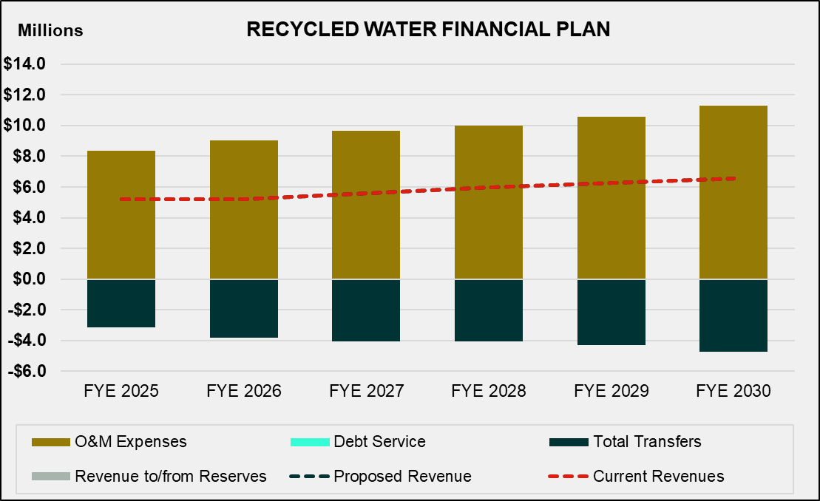

Proposed Financial Plan
The projected financial plan under the status quo scenario in Table 6-5 shows that the City’s current rate revenues are not sufficient to sustain the recycled water utility. Table 6-6 shows the proposed revenue adjustments for the study period, effective in July of each fiscal year. The proposed revenue adjustments were developed to allow the City to decrease the recycled water utility’s dependence on the water utility over the long term and to fully fund recycled water operating costs.

Table 6-6: Proposed Recycled Water Revenue Adjustments
 | A | B | C
Line | Fiscal Year | Revenue Adjustment | Month Effective
1 | 2026 | 5.0% | July
2 | 2027 | 5.0% | July
3 | 2028 | 9.0% | July
4 | 2029 | 9.0% | July
5 | 2030 | 9.0% | July

Table 6-7 shows the projected recycled water financial plan with the proposed revenue adjustments from Table 6-6. Though transfers from the Water Operating Fund (Line 13) are required in all years of the study to avoid a negative cash flow in the fund, the projections show that the magnitude of the required transfer will decrease throughout the forecast. With the proposed revenue adjustments, the recycled water fund will require $6.7 million less in transfers from the Water Operating Fund to remain solvent over the forecast.
Table 6-7: Projected Recycled Water Financial Plan (Proposed Revenue Adjustments)
 | A | B | C | D | E | F | G
Line | Financial Plan | FY 2025 | FY 2026 | FY 2027 | FY 2028 | FY 2029 | FY 2030
 | Revenues
1 | Rate Revenues | $5,214,326 | $5,214,326 | $5,574,115 | $5,958,729 | $6,256,665 | $6,569,498
2 | Revenue Adjustments | $0 | $260,716 | $571,347 | $1,202,025 | $1,938,817 | $2,810,231
3 | Other Revenues | $0 | $0 | $0 | $0 | $0 | $0
4 | Total Revenues | $5,214,326 | $5,475,043 | $6,145,462 | $7,160,753 | $8,195,482 | $9,379,729
 | O&M Expenses
5 | Water Administration | $0 | $0 | $0 | $0 | $0 | $0
6 | Pumping | $377,997 | $398,706 | $417,511 | $435,489 | $452,507 | $470,178
7 | Water Line Maintenance | $449,552 | $472,405 | $491,595 | $508,985 | $524,270 | $540,014
8 | Environmental Engr. | $113,445 | $119,294 | $124,181 | $128,593 | $132,451 | $136,424
9 | Non-Potable Wtr. Purch. | $7,177,500 | $7,779,050 | $8,361,592 | $8,668,135 | $9,183,980 | $9,877,378
10 | Water Resources | $97,454 | $103,402 | $108,122 | $112,215 | $115,582 | $119,049
11 | Customer Service | $139,938 | $145,221 | $150,158 | $154,968 | $159,617 | $164,405
12 | Total | $8,355,886 | $9,018,078 | $9,653,159 | $10,008,384 | $10,568,406 | $11,307,448
13 | Transfer from Water Capital | ($3,141,560) | ($3,543,035) | ($3,507,698) | ($2,847,630) | ($2,372,924) | ($1,927,719)
14 | Net Cash Flow | $0 | $0 | $0 | $0 | $0 | $0
15 | Beginning Fund Balance | $0 | $0 | $0 | $0 | $0 | $0
16 | Ending Fund Balance | $0 | $0 | $0 | $0 | $0 | $0

Figure 6-2 shows the proposed financial plan in graphical format with the revenue adjustments in Table 6-6. The proposed revenues, shown as the dotted dark blue line, allow the City to decrease the required transfers (black stacked bars) from the Water Operating Fund over the course of the forecast.

Figure 6-2: Projected Water Financial Plan (Proposed Revenue Adjustments)

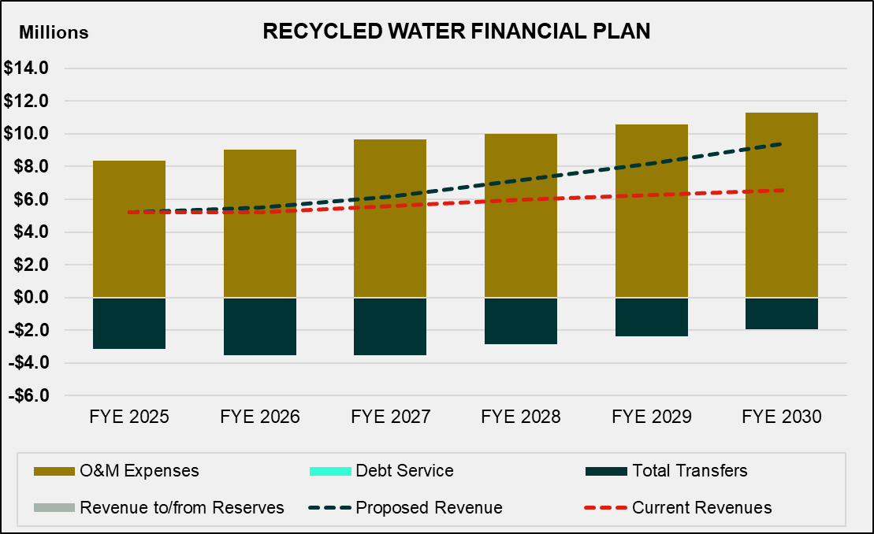

Recycled Water Cost of Service

The cost-of-service analysis for the recycled water enterprise follows the same methodology as for the potable water operations.

Revenue Requirement Determination
Table 7-1 shows the revenue requirement derivation for FY 2026. The revenue requirement is comprised of the Operating (Column B, Line 12) and Capital (Column C, Line 12) revenue requirements. The adjustment for cash balance (Line 10) is equal to the net cash flow for FY 2026 (Table 6-7, Column C, Line 13).

Table 7-1: Recycled Water Revenue Requirement
 | A | B | C | D
Line | Recycled Water FY 2026 Requirements | Operating | Capital | Total
 | Revenue Requirements
1 | O&M Expenses
2 | Pumping | $398,706 |  | $398,706
3 | Water Line Maintenance | $472,405 |  | $472,405
4 | Environmental Engr. | $119,294 |  | $119,294
5 | Non-Potable Wtr. Purch. | $7,779,050 |  | $7,779,050
6 | Water Resources | $103,402 |  | $103,402
7 | Customer Service | $145,221 |  | $145,221
8 | Transfer from Water Operating |  | ($3,543,035) | ($3,543,035)
9 | Total Revenue Requirements | $9,018,078 | -$3,543,035 | $5,475,043
 | Less: Adjustments
10 | Adjustment for Cash Balance | $0 |  | $0
11 | Total Adjustments | $0 |  | $0
12 | Revenue Requirement from Rates | $9,018,078 | -$3,543,035 | $5,475,043

Allocation of Expenses to Cost Components
Expenses for the recycled water enterprise are allocated in the same manner as expenses for the potable water operation. The allocation basis for each expense is chosen based on the type of cost for each line item and the proportion of those costs associated with each cost causation component (Base or average demand, Max Day, Max Hour, General, etc.). The allocation is based on the design basis of the different components of the recycled water system and is as shown in Table 7-2.

Actual O&M expenses are then allocated to the cost components, as shown in Table 7-3. The O&M allocation percentages (Line 8) are then used to allocate the Operating revenue requirement (Table 7-1, Column B, Line 10) in a later section.

Table 7-2: Recycled Water O&M Allocation Factors
 | A | B | C | D | E | F | G | H | I
Line | RW O&M Allocation | Supply | Base Delivery | Max Day | Max Hour | Meters | Customer | General | Total
1 | Supply | 100% |  |  |  |  |  |  | 100%
2 | Treatment |  | 100% |  |  |  |  |  | 100%
3 | T&D |  | 50.5% | 27.8% | 21.7% |  |  |  | 100%
4 | Meters |  |  |  |  | 100% |  |  | 100%
5 | Customer Service |  |  |  |  |  | 100% |  | 100%
6 | General |  |  |  |  |  |  | 100% | 100%

Table 7-3: Recycled Water O&M Allocations
 | A | B | C | D | E | F | G | H | I
Line | RW O&M Cost | Supply | Base Delivery | Max Day | Max Hour | Meters | Customer | General | Total
1 | Supply | $8,177,756 | $0 | $0 | $0 | $0 | $0 | $0 | $8,177,756
2 | Treatment | $0 | $29,823 | $0 | $0 | $0 | $0 | $0 | $29,823
3 | T&D | $0 | $164,481 | $90,465 | $70,727 | $0 | $0 | $0 | $325,673
4 | Meters | $0 | $0 | $0 | $0 | $188,962 | $0 | $0 | $188,962
5 | Customer Service | $0 | $0 | $0 | $0 | $0 | $47,240 | $0 | $47,240
6 | General | $0 | $0 | $0 | $0 | $0 | $0 | $248,623 | $248,623
7 | Total O&M Expenses | $8,177,756 | $194,304 | $90,465 | $70,727 | $188,962 | $47,240 | $248,623 | $9,018,078
8 | O&M Allocation | 90.7% | 2.2% | 1.0% | 0.8% | 2.1% | 0.5% | 2.8% | 100.0%

Units of Service
Once all expenses have been allocated to the appropriate cost components, the next step is to determine the units of service from which the costs will be recovered. The standard units are number of customers, EMUs, annual water use, and extra capacity units. The numbers shown in the tables of this section are rounded. Therefore, hand calculations based on the displayed numbers, such as summing or multiplying, may not equal the exact results shown.

Customer and Meter Equivalents
Table 7-4 summarizes customer and meter units. The number of recycled water accounts (Column D) can also be found in Table 6-1. EMUs account for the potential demand that larger meters place on the system compared to demand from the smallest meter, which for this study is the 5/8-inch meter. EMUs are derived by multiplying the AWWA ratio (Column C) by the number of accounts at a given meter size. The rationale for this approach was described in Section 4 – Customer and Meter Equivalents.

Table 7-4: Customer and Equivalent Meter Units
 | A | B | C | D | E
Line | Meter Size | Capacity (gpm) | AWWA Ratio | RW Meters | RW EMUs
1 | 5/8" | 20 | 1.00 | 0 | 0
2 | 3/4" | 30 | 1.50 | 1 | 2
3 | 1" | 50 | 2.50 | 35 | 88
4 | 1 1/2" | 100 | 5.00 | 87 | 435
5 | 2" | 160 | 8.00 | 305 | 2,440
6 | 3" | 350 | 17.50 | 35 | 613
7 | 4" | 630 | 31.50 | 14 | 441
8 | 6" | 1,300 | 65.00 | 2 | 130
9 | 8" | 2,400 | 120.00 | 1 | 120
10 | 10" | 3,800 | 190.00 | 0 | 0
11 | Total |  |  | 480 | 4,268

Recycled Cost of Service
Since the recycled enterprise customers are mainly irrigation customers with similar characteristics, it is unnecessary to calculate peaking factors and extra capacity units. It is common to implement a uniform rate for recycled water use. All supply, base, and peaking costs will be allocated and recovered on the basis of recycled water used. Table 7-5 summarizes the recycled water cost-of-service analysis. The operating (Line 1), capital (Line 2), and total revenue requirements (Line 3) are from Table 7-1. The operating revenue requirement (Column I, Line 1) is allocated based on the operating allocation percentages (Table 7-3, Line 8).

Table 7-5: Recycled Water Cost of Service
 | A | B | C | D | E | F | G | H | I
Line | Recycled Cost of Service | Supply | Base Delivery | Max Day | Max Hour | Meter | Customer | General | Total
1 | Operating Expenses | $8,177,756 | $194,304 | $90,465 | $70,727 | $188,962 | $47,240 | $248,623 | $9,018,078
2 | Capital Expenses | ($3,543,035) | $0 | $0 | $0 | $0 | $0 | $0 | ($3,543,035)
3 | Total Cost of Service | $4,634,721 | $194,304 | $90,465 | $70,727 | $188,962 | $47,240 | $248,623 | $5,475,043
4 | Allocation of General Cost | $220,476 | $9,243 | $4,303 | $3,365 | $8,989 | $2,247 | ($248,623) | $0
5 | Allocation of Peaking Cost to Meter |  |  | ($75,814) | ($59,273) | $135,088 |  |  | $0
6 | Total Adjusted Cost of Service | $4,855,197 | $203,548 | $18,954 | $14,818 | $333,038 | $49,488 | $0 | $5,475,043
7 | Unit of Service | 2,048,949 | 2,048,949 | 2,048,949 | 2,048,949 | 4,268 | 5,760
8 | Unit | hcf | hcf | hcf | hcf | equiv. meter | annual bills
9 | Unit Cost | $2.37 | $0.10 | $0.009 | $0.007 | $6.50 | $8.59

Recycled Water Rates
As with the potable rates, recycled rates include a fixed monthly meter charge and a volumetric rate. As shown in Table 7-6, the fixed charge includes a Meter component (Table 7-5, Column F, Line 9), that scales with size of the meter using the AWWA capacity ratios (Column B). The Customer component (Table 7-5, Column G, Line 9) is the same for all meter sizes. The sum of these two components is the total proposed charge (Column E).

Table 7-6: Recycled Water Meter Charges
 | A | B | C | D | E
Line | Meter Size | AWWA Ratio | Meter | Customer | Proposed Charge
1 | 5/8" | 1.00 | $6.50 | $8.59 | $15.10
2 | 3/4" | 1.50 | $9.76 | $8.59 | $18.35
3 | 1" | 2.50 | $16.26 | $8.59 | $24.85
4 | 1 1/2" | 5.00 | $32.52 | $8.59 | $41.11
5 | 2" | 8.00 | $52.03 | $8.59 | $60.62
6 | 3" | 17.50 | $113.81 | $8.59 | $122.40
7 | 4" | 31.50 | $204.86 | $8.59 | $213.45
8 | 6" | 65.00 | $422.72 | $8.59 | $431.31
9 | 8" | 120.00 | $780.41 | $8.59 | $789.00
10 | 10" | 190.00 | $1,235.64 | $8.59 | $1,244.24

Table 7-7 show the proposed recycled water volumetric charge, which is equal to the rounded total of the unit rates calculated in Table 7-5 for the Base and peaking components.

Table 7-7: Recycled Water Volumetric Charge ($/hcf)
 | A | B | C | D
Line | Supply | Base Delivery | Max Day and Max Hour | Proposed Rate
1 | $2.37 | $0.10 | $0.016 | $2.49

Table 7-8 and Table 7-9 show the proposed recycled water rates for the study period.

Table 7-8: Proposed Recycled Water Service Charge ($/meter size)
 | A | B | C | D | E | F | G
Line | Service Charges | FY 2025 (Current) | FY 2026 | FY 2027 | FY 2028 | FY 2029 | FY 2030
 | Recycled Water
1 | 5/8" | $14.88 | $15.10 | $15.85 | $16.64 | $18.14 | $19.77
2 | 3/4" | $17.20 | $18.35 | $19.26 | $20.23 | $22.05 | $24.03
3 | 1" | $21.85 | $24.85 | $26.09 | $27.40 | $29.86 | $32.55
4 | 1 1/2" | $33.46 | $41.11 | $43.16 | $45.32 | $49.40 | $53.85
5 | 2" | $47.40 | $60.62 | $63.65 | $66.83 | $72.85 | $79.40
6 | 3" | $91.53 | $122.40 | $128.52 | $134.95 | $147.09 | $160.33
7 | 4" | $156.56 | $213.45 | $224.12 | $235.33 | $256.51 | $279.59
8 | 6" | $312.18 | $431.31 | $452.88 | $475.52 | $518.32 | $564.97
9 | 8" | $567.67 | $789.00 | $828.45 | $869.87 | $948.16 | $1,033.49
10 | 10" | $892.93 | $1,244.24 | $1,306.45 | $1,371.77 | $1,495.23 | $1,629.80
Table 7-9: Proposed Recycled Water Usage Rates ($/hcf of water)
 | A | B | C | D | E | F | G | H
Line | Customer Class | Monthly Tiers (hcf) | FY 2025 (Current) | FY 2026 | FY 2027 | FY 2028 | FY 2029 | FY 2030
1 | Recycled | Uniform | $2.40 | $2.49 | $2.61 | $2.74 | $2.99 | $3.26

Wastewater Financial Plan

This report section details the wastewater enterprise’s long-term financial plan, based on the projected revenues, expenses, debt service, and capital project costs. Raftelis modeled the financial plan without revenue adjustments (status quo) and with proposed revenue adjustments to ensure the financial sustainability and solvency of the wastewater utility.

Projection of Customer Data
City staff provided the actual units for residential customers and billed usage for non-residential customers for FY 2024. Raftelis forecasted these using a growth factor of 2 percent for each customer class. Table 8-1 shows a summary of the results of the forecast.

Table 8-1: Projected Wastewater Units and Usage (HCF)
 | A | B | C | D | E | F | G
Line | Customer Class | FY 2025 | FY 2026 | FY 2027 | FY 2028 | FY 2029 | FY 2030
 | Units
1 | Single Family | 33,051 | 33,712 | 34,386 | 35,074 | 35,776 | 36,491
2 | Multi-Family | 22,118 | 22,560 | 23,011 | 23,471 | 23,941 | 24,420
3 | Total Units | 55,169 | 56,272 | 57,398 | 58,546 | 59,716 | 60,911
 | Billed Usage (hcf)
4 | Commercial | 1,922,256 | 1,960,701 | 1,999,915 | 2,039,914 | 2,080,712 | 2,163,941
5 | Industrial | 778,668 | 794,241 | 810,126 | 826,329 | 842,855 | 876,569
6 | Government | 208,023 | 212,183 | 216,427 | 220,756 | 225,171 | 234,177
7 | City | 20,458 | 20,867 | 21,285 | 21,710 | 22,145 | 23,030
8 | Total Billed Usage | 2,929,405 | 2,987,993 | 3,047,753 | 3,108,708 | 3,170,883 | 3,297,718

Projected Revenues
City staff provided the actual FY 2023 and FY 2024 revenues and budgeted FY 2025 revenues for the wastewater utility, which were used to project revenues for the remainder of the study period. Table 8-2 shows the projected wastewater revenues based on the demand in Table 8-1 and the current rates in Table 1-3.

If the City continues with existing rates, the City expects modest increases in wastewater rate revenues for all years of the study based on account growth. The investment income (Line 3) is calculated using the reserve interest rate (Table 2-2, Line 2). Miscellaneous revenues include interdepartmental transfers and customer late charges.

Table 8-2: Projected Wastewater Revenues
 | A | B | C | D | E | F | G
Line | Revenue | FY 2025 | FY 2026 | FY 2027 | FY 2028 | FY 2029 | FY 2030
1 | City Rate Revenue | $12,780,128 | $13,035,731 | $13,296,446 | $13,562,375 | $13,833,622 | $14,199,713
 | Other Revenue
2 | IEUA Revenue | $19,812,465 | $20,208,714 | $20,612,889 | $21,025,147 | $21,445,649 | $21,874,562
3 | Interest Income | $218,678 | $54,152 | $57,128 | $57,111 | $60,567 | $64,600
4 | Misc | $434,832 | $438,609 | $442,461 | $446,390 | $450,398 | $454,486
5 | Total | $33,246,103 | $33,735,251 | $34,404,834 | $35,084,609 | $35,781,292 | $36,581,592

Projected O&M Expenses
City staff provided the actual FY 2024 O&M expenses and budgeted FY 2025 O&M expenses for the wastewater utility. Table 8-3 shows the projected O&M expenses for the study period, inflated for FY 2026 and beyond using the expense inflation factors (Table 2-3).

Table 8-3: Projected Wastewater O&M Expenses
 | A | B | C | D | E | F | G
Line | O&M Expenses | FY 2025 | FY 2026 | FY 2027 | FY 2028 | FY 2029 | FY 2030
 | Department
1 | Sewer Administration | $2,508,690 | $2,621,620 | $2,720,045 | $2,801,646 | $2,885,696 | $2,972,266
2 | Sewer Maintenance | $3,688,268 | $3,832,055 | $3,964,414 | $4,083,347 | $4,205,847 | $4,332,023
3 | Environmental Engr. | $1,654,413 | $1,713,751 | $1,770,259 | $1,823,367 | $1,878,068 | $1,934,410
4 | Sewer Resources | $1,021,946 | $1,052,856 | $1,084,573 | $1,117,110 | $1,150,623 | $1,185,142
5 | Customer Service | $1,347,229 | $1,393,835 | $1,438,899 | $1,482,066 | $1,526,528 | $1,572,324
6 | IEUA Treatment | $19,812,465 | $20,208,714 | $20,612,889 | $21,025,147 | $21,445,649 | $21,874,562
7 | Total | $30,033,011 | $30,822,831 | $31,591,079 | $32,332,683 | $33,092,412 | $33,870,728

Debt Service
The City currently has no existing debt for the wastewater enterprise. To fund the capital program, Raftelis recommends one new debt issuance in FY 2028. The terms for this debt issuance are assumed to be a 30-year bond at 5.0 percent interest with a 2.0 percent issuance cost. It is assumed an additional reserve fund would not need to be created for the debt. Future debt will be included in the debt service coverage requirement as shown in the financial planning sections. The proposed annual debt service for this bond issue is shown in Table 8-4.

Table 8-4: Projected Wastewater Debt Issuance
 | A | B | C | D | E | F | G
Line | Proposed Debt Service | FY 2025 | FY 2026 | FY 2027 | FY 2028 | FY 2029 | FY 2030
1 | Proposed Bond Issue | $0 | $0 | $0 | $20,000,000 | $0 | $0
2 | Bond Proceeds | $0 | $0 | $0 | $19,600,000 | $0 | $0
3 | Annual Debt Service | $0 | $0 | $0 | $1,301,029 | $1,301,029 | $1,301,029

Capital Projects
City staff provided the CIP for the wastewater utility for the study period. Table 8-5 presents the forecasted CIP for the five-year period in inflated future dollars (in years after 2025) (Line 11) using the inflation factors (Table 2-3, Line 7).

Table 8-5: Projected Wastewater Capital Projects
 | A | B | C | D | E | F | G
Line | Capital Projects | FY 2025 | FY 2026 | FY 2027 | FY 2028 | FY 2029 | FY 2030
1 | Municipal Service Projects | $150,000 | $150,000 | $150,000 | $150,000 | $150,000 | $150,000
2 | Sewer System Evaluations and Enhancements | $150,000 | $150,000 | $75,000 | $75,000 | $75,000 | $75,000
3 | Sewer Master Plan Updates | $200,000 | $150,000 | $150,000 | $150,000 | $150,000 | $150,000
4 | Archibald Avenue Sewer Diversion | $2,840,231 | $0 | $0 | $0 | $0 | $0
5 | Laurel Avenue (G Street to Holt Blvd) Sewer Main Imp. | $2,040,000 | $0 | $0 | $0 | $0 | $0
6 | Piemonte Overlay Sewer Imp. | $2,541,910 | $0 | $0 | $0 | $0 | $0
7 | Edison Avenue and Bon View Avenue Sewer Main Imp. | $2,000,000 | $0 | $0 | $0 | $0 | $0
8 | Nocta Street and Allyn Avenue Sewer Imp. | $1,222,268 | $0 | $0 | $0 | $0 | $0
9 | Nocta Street and Allyn Avenue Sewer Imp. | $1,142,000 | $0 | $0 | $0 | $0 | $0
10 | Sultana Avenue and Cherry Avenue Sewer Imp. | $1,320,000 | $0 | $0 | $0 | $0 | $0
11 | Nocta Street Sewer Service Laterals | $880,000 | $0 | $0 | $0 | $0 | $0
12 | Customer Service CIS Billing System Upgrade | $115,000 | $35,000 | $35,000 | $35,000 | $0 | $0
13 | G Street Sanitary Sewer Main (DIF Revenues) | $880,000 | $0 | $0 | $0 | $0 | $0
14 | N. Vineyard Sanitary Sewer Project (DIF Revenues) | $8,500,000 | $1,500,000 | $7,805,973 | $0 | $0 | $0
15 | FY 2024-25 Sewer Main lining Imp. | $3,000,000 | $3,000,000 | $3,000,000 | $3,000,000 | $3,000,000 | $3,000,000
16 | OMSC BioSwale | $75,000 | $0 | $0 | $0 | $0 | $0
17 | **Advanced Water Purification Facility | $250,000 | $250,000 | $250,000 | $250,000 | $250,000 | $250,000
18 | Sewer Imp. (10 Freeway) | $0 | $6,000,000 | $0 | $0 | $0 | $0
19 | *Municipal Service Center Relocation | $800,000 | $800,000 | $0 | $20,400,000 | $19,800,000 | $0
20 | Sports Complex Offsite Utilities Projects and Sewer Imp at Vineyard | $28,242,500 | $25,654,883 | $0 | $0 | $0 | $0
12 | Total Inflated CIP | $56,348,909 | $37,689,883 | $11,465,973 | $24,060,000 | $23,425,000 | $3,625,000
13 | Capital Expenses | $5,530,410 | $5,776,550 | $5,991,966 | $6,171,725 | $6,356,876 | $6,547,583
14 | Total Capital Expenses | $61,879,319 | $43,466,433 | $17,457,939 | $30,231,725 | $29,781,876 | $10,172,583

Table 8-6 shows the proposed capital financing plan for the wastewater utility. The City plans to fully fund its wastewater CIP for all years of the study (Line 2). The inflated project costs (Line 1) are shown because the CIP provided to Raftelis accounted for inflation. Expenses (Line 4) include utilities and other expenses that are appropriate to capitalize. The CIP will be funded from a mix of sources. There is an expected general fund transfer to cover the costs of the sports complex in FY 2025 and FY 2026 and expected proceeds from sales of public works land in FY 2027 and FY 2028. Raftelis recommends a $20,000,000 debt issuance in FY 2028. Rate revenue will cover all necessary CIP spending that remains.

Table 8-6: Wastewater Capital Financing Plan
 | A | B | C | D | E | F | G
Line | Capital Financing Plan | FY 2025 | FY 2026 | FY 2027 | FY 2028 | FY 2029 | FY 2030
1 | Inflated CIP Costs | $3,675,965 | $4,115,769 | $6,240,255 | $11,222,996 | $2,088,201 | $2,038,578
2 | Spending Factor | 100% | 100% | 100% | 100% | 100% | 100%
3 | CIP to Spend | $56,348,909 | $37,689,883 | $11,465,973 | $24,060,000 | $23,425,000 | $3,625,000
4 | Capital Expenses | $5,530,410 | $5,776,550 | $5,991,966 | $6,171,725 | $6,356,876 | $6,547,583
5 | Total CIP | $61,879,319 | $43,466,433 | $17,457,939 | $30,231,725 | $29,781,876 | $10,172,583
 | Capital Financing
6 | Rate Funded | $23,881,887 | $16,811,550 | $16,457,939 | $431,725 | $19,881,876 | $10,172,583
7 | Debt Funded | $0 | $0 | $0 | $19,600,000 | $0 | $0
8 | Proceeds from PW Land Sales |  |  | $8,160,000 | $7,920,000
9 | General Fund Transfer for Sports Complex | $28,242,500 | $25,654,883
10 | DIF Funded | $9,754,932 | $1,000,000 | $1,000,000 | $2,040,000 | $1,980,000 | $0
11 | Total | $61,879,319 | $43,466,433 | $17,457,939 | $30,231,725 | $29,781,876 | $10,172,583

Current Financial Plan – Status Quo
Table 8-7 shows the projected wastewater financial plan without revenue adjustments (also referred to as status quo). Rate revenues and other revenues are derived from projected revenues (Table 8-2). O&M expenses are derived from projected O&M expenses (Table 8-3).

The net cash flow (Line 17) is calculated by subtracting O&M expenses (Line 13) and debt service and capital costs (Line 15) from the total revenues (Line 6). Net operating revenue (Line 18) is equal to total revenues (Line 6) less O&M expenses (Line 13). Please note that Table 8-7 only shows the financial plan for the operating fund. In the model, the operating fund is prevented from transferring additional revenue to the capital fund if such a transfer would drop the operating reserve below its reserve requirements. As a result, the net cash flow is positive in years FY 2026-FY 2030. However, this does not show the results for the capital fund, which would become negative in such a scenario.

Figure 8-2 shows the results when both funds are included.
Table 8-7: Projected Wastewater Financial Plan (Status Quo)
 | A | B | C | D | E | F | G
Line | Financial Plan | FY 2025 | FY 2026 | FY 2027 | FY 2028 | FY 2029 | FY 2030
 | Revenues
1 | Rate Revenues | $12,780,128 | $13,035,731 | $13,296,446 | $13,562,375 | $13,833,622 | $14,199,713
2 | Revenue Adjustments | $0 | $0 | $0 | $0 | $0 | $0
3 | IEUA Revenue | $19,812,465 | $20,208,714 | $20,612,889 | $21,025,147 | $21,445,649 | $21,874,562
4 | Interest Income | $218,678 | $54,152 | $57,128 | $57,111 | $60,567 | $64,600
5 | Other Revenues | $434,832 | $438,609 | $442,461 | $446,390 | $450,398 | $454,486
6 | Total Revenues | $33,246,103 | $33,735,251 | $34,404,834 | $35,084,609 | $35,781,292 | $36,581,592
 | O&M Expenses
7 | Sewer Administration | $2,508,690 | $2,621,620 | $2,720,045 | $2,801,646 | $2,885,696 | $2,972,266
8 | Sewer Maintenance | $3,688,268 | $3,832,055 | $3,964,414 | $4,083,347 | $4,205,847 | $4,332,023
9 | Environmental Engr. | $1,654,413 | $1,713,751 | $1,770,259 | $1,823,367 | $1,878,068 | $1,934,410
10 | Sewer Resources | $1,021,946 | $1,052,856 | $1,084,573 | $1,117,110 | $1,150,623 | $1,185,142
11 | Customer Service | $1,347,229 | $1,393,835 | $1,438,899 | $1,482,066 | $1,526,528 | $1,572,324
12 | IEUA Treatment | $19,812,465 | $20,208,714 | $20,612,889 | $21,025,147 | $21,445,649 | $21,874,562
13 | Total | $30,033,011 | $30,822,831 | $31,591,079 | $32,332,683 | $33,092,412 | $33,870,728
 | Debt Service and Capital
14 | Transfer to Capital Fund | $36,442,105 | $2,694,287 | $2,601,761 | $2,538,122 | $2,460,945 | $2,477,074
15 | Total | $36,442,105 | $2,694,287 | $2,601,761 | $2,538,122 | $2,460,945 | $2,477,074
16 | Total Revenue Required | $66,475,116 | $33,517,118 | $34,192,840 | $34,870,804 | $35,553,357 | $36,347,802
17 | Net Cash Flow | ($33,229,013) | $218,134 | $211,994 | $217,057 | $231,188 | $237,043
18 | Net Operating Revenue | $3,213,092 | $2,912,420 | $2,813,755 | $2,755,179 | $2,692,133 | $2,714,117
19 | Beginning Fund Balance | $42,238,294 | $9,009,281 | $9,227,414 | $9,439,408 | $9,656,465 | $9,887,653
20 | Ending Fund Balance | $9,009,281 | $9,227,414 | $9,439,408 | $9,656,465 | $9,887,653 | $10,124,696
21 | Reserve Target | $7,508,253 | $7,705,708 | $7,897,770 | $8,083,171 | $8,273,103 | $8,467,682

Figure 8-1 shows the projected wastewater financial plan under the status quo scenario in graphical format. The stacked bars represent the O&M expenses (brown) and capital costs (black). The light gray bars show the changes to cash balances: if the gray bars are below the stacked bars, then the City will be drawing from cash reserves, and vice versa. There are no debt service costs in the status quo scenario. The proposed revenue line and the current revenue line are also superimposed on each other in this status quo scenario, since there are no rate adjustments. The dark blue line, which represents current revenues, shows that the City’s current wastewater revenues are sufficient to fund its operating costs (brown bars) and a very small amount of capital. However, the full impact of the planned capital spending can be seen in

Figure 8-2, which includes the combined ending balances of the water and capital reserve funds. Without rate adjustments or debt issuances, the combined operating and capital reserve funds would drop below target requirements in FY 2028 and would become insolvent by FY 2029.

Figure 8-1: Projected Wastewater Financial Plan (Status Quo)
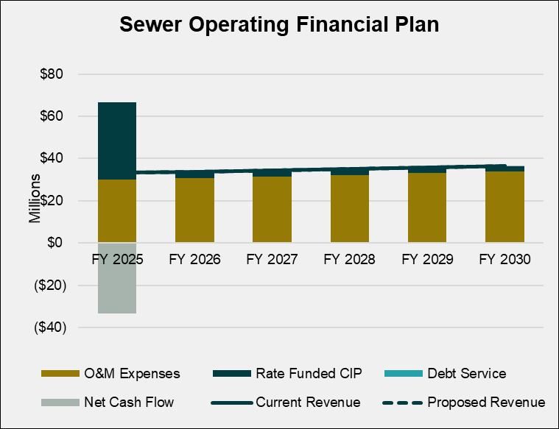

Figure 8-2: Wastewater Reserves (Status Quo)

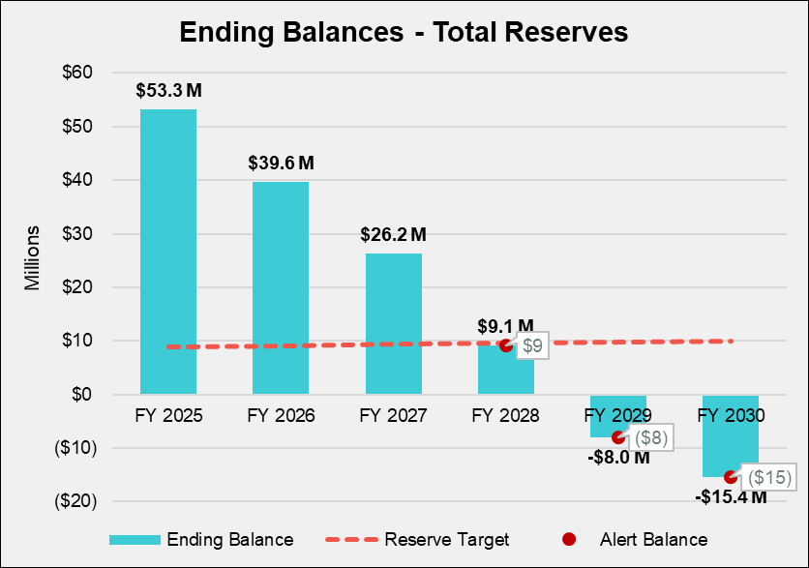

Proposed Financial Plan
The projected financial plan under the status quo scenario in Table 8-7, combined with Figure 8-2, show that the City’s wastewater utility would quickly draw down reserves and threaten to become insolvent. Table 8-8 shows the proposed revenue adjustments for the study period, effective in July of each year. The City proposes to implement similar increases overtime to avoid the need for large increases in the later years of the forecast.

Table 8-8: Proposed Wastewater Revenue Adjustments
 | A | B | C
Line | Fiscal Year | Revenue Adjustment | Month Effective
1 | 2026 | 5% | July
2 | 2027 | 5% | July
3 | 2028 | 5% | July
4 | 2029 | 5% | July
5 | 2030 | 5% | July

Table 8-9 shows the projected wastewater financial plan with the proposed revenue adjustments from Table 8-8. The net cash flow (Line 17) is significantly negative in the current year, when the City plans to cash finance a significant amount of capital spending from reserves. In all future years, the net cash flow is positive as a result of the proposed wastewater revenue adjustments. The proposed revenue adjustments also allow the utility to finance all planned capital spending without dropping below combined operating and reserve fund reserve requirements, as seen in Figure 8-4.

Table 8-9: Projected Wastewater Financial Plan (Proposed Revenue Adjustments)
 | A | B | C | D | E | F | G
Line | Financial Plan | FY 2025 | FY 2026 | FY 2027 | FY 2028 | FY 2029 | FY 2030
 | Revenues
1 | Rate Revenues | $12,780,128 | $13,035,731 | $13,296,446 | $13,562,375 | $13,833,622 | $14,199,713
2 | Revenue Adjustments | $0 | $651,787 | $1,362,886 | $2,137,769 | $2,981,232 | $3,923,119
3 | IEUA Revenue | $19,812,465 | $20,208,714 | $20,612,889 | $21,025,147 | $21,445,649 | $21,874,562
4 | Interest Income | $218,678 | $54,152 | $57,128 | $57,111 | $60,567 | $64,600
5 | Other Revenues | $434,832 | $438,609 | $442,461 | $446,390 | $450,398 | $454,486
6 | Total Revenues | $30,547,518 | $31,675,692 | $32,528,936 | $33,251,385 | $34,153,913 | $35,129,669
 | O&M Expenses
7 | Sewer Administration | $2,508,690 | $2,621,620 | $2,720,045 | $2,801,646 | $2,885,696 | $2,972,266
8 | Sewer Maintenance | $3,688,268 | $3,832,055 | $3,964,414 | $4,083,347 | $4,205,847 | $4,332,023
9 | Environmental Engr. | $1,654,413 | $1,713,751 | $1,770,259 | $1,823,367 | $1,878,068 | $1,934,410
10 | Sewer Resources | $1,021,946 | $1,052,856 | $1,084,573 | $1,117,110 | $1,150,623 | $1,185,142
11 | Customer Service | $1,347,229 | $1,393,835 | $1,438,899 | $1,482,066 | $1,526,528 | $1,572,324
12 | IEUA Treatment | $19,812,465 | $20,208,714 | $20,612,889 | $21,025,147 | $21,445,649 | $21,874,562
13 | Total | $30,033,011 | $30,822,831 | $31,591,079 | $32,332,683 | $33,092,412 | $33,870,728
 | Debt Service and Capital
14 | Transfer to Capital Fund | $36,376,926 | $3,276,919 | $3,891,247 | $3,293,677 | $4,052,651 | $5,004,246
15 | Total | $36,376,926 | $3,276,919 | $3,891,247 | $3,293,677 | $4,052,651 | $5,004,246
16 | Total Revenue Required | $66,409,938 | $34,099,750 | $35,482,326 | $36,927,388 | $38,446,091 | $40,176,002
17 | Net Cash Flow | ($33,163,834) | $289,243 | $289,482 | $301,403 | $325,377 | $340,478
18 | Net Operating Revenue | $3,213,092 | $3,566,162 | $4,180,729 | $4,896,109 | $5,679,056 | $6,645,753
19 | Beginning Fund Balance | $42,238,294 | $9,074,459 | $9,363,703 | $9,653,185 | $9,954,588 | $10,279,965
20 | Ending Fund Balance | $9,074,459 | $9,363,703 | $9,653,185 | $9,954,588 | $10,279,965 | $10,620,444
21 | Reserve Target | $7,508,253 | $7,705,708 | $7,897,770 | $8,083,171 | $8,273,103 | $8,467,682

Figure 8-3 shows the proposed financial plan in graphical format with the revenue adjustments in Table 8-8. The proposed revenues, shown as the dotted dark blue line, allow the City to fund its operating costs for the study period. The current and proposed revenue lines are below the height of the bars in FY 2025 because the City plans to lower its cash reserves in order to fund wastewater capital spending.

Figure 8-3: Projected Wastewater Financial Plan (Proposed Revenue Adjustments)
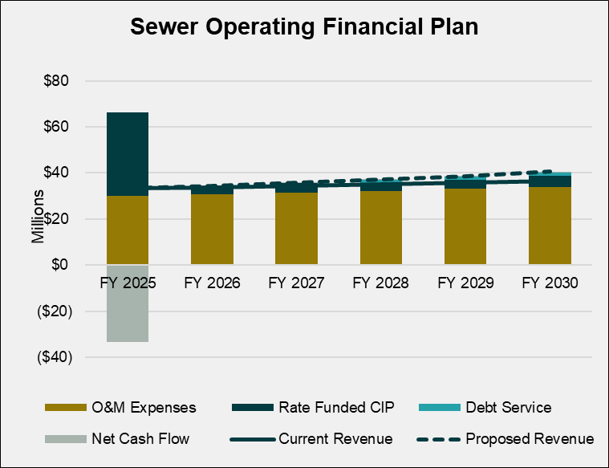

Projected reserves are shown in Figure 8-4.

Figure 8-4: Projected Reserves (Proposed Revenue Adjustments)
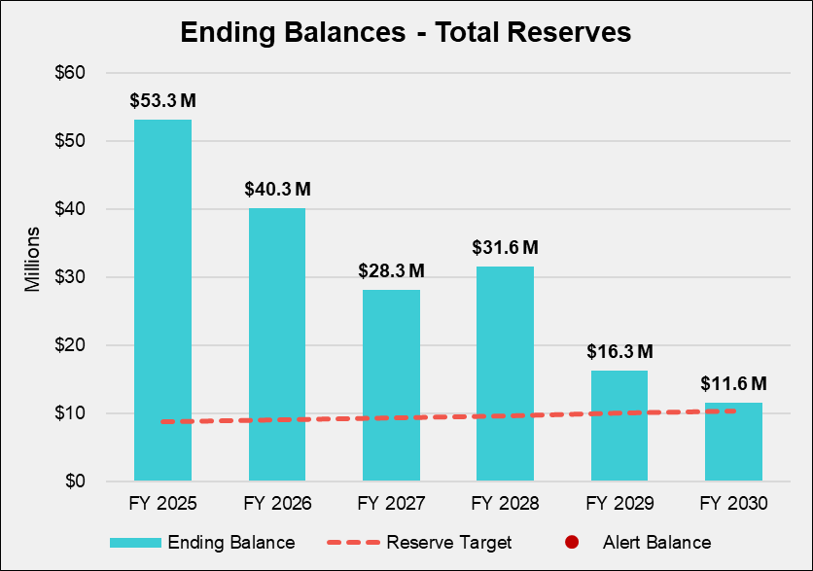

Wastewater Cost of Service and Rates

This section of the report details the cost-of-service analysis and rate calculation process to determine the proposed wastewater rates. The goal of this process is to determine the cost of providing wastewater service to each of the City’s wastewater customer classes and to ensure equity and fairness among the various classes.

Process and Approach
The cost-of-service analysis utilized to develop the wastewater rates followed the guidelines for allocating costs outlined in the WEF Manual No. 27. The cost-of-service analysis and rate design process consists of six major steps, as outlined below:

- Determine the revenue requirement, equal to the revenue to be recovered from rates.
- Functionalize O&M expenses and capital assets into functional categories such as flow, customer, general, and treatment.
- Develop customer class characteristics and units of service by cost causation component.
- Calculate the cost causation component unit rates by dividing the total cost in each cost causation component by the total units of service for that component.
- Calculate the cost for each customer class by multiplying the unit cost by the units of service for each customer class.
- Design rates to meet the City’s objectives.

Revenue Requirement Determination
Table 9-1 shows the revenue requirement derivation for FY 2026. The revenue requirement is comprised of the Operating (Column B, Line 9) and Capital (Column C, Line 9) revenue requirements. The adjustment for cash balance (Line 7) is equal to the net cash flow for FY 2026 (Table 8-9, Column C, Line 17).

Table 9-1: Wastewater Revenue Requirement
 | A | B | C | D
Line | Wastewater FY 2024 Revenue Requirements | Operating | Capital | Total
 | Revenue Requirements
1 | O&M Expenses | $30,822,831 |  | $30,822,831
2 | Transfer to Capital Fund |  | $3,276,919 | $3,276,919
3 | Subtotal | $30,822,831 | $3,276,919 | $34,099,750
 | Other Revenue
4 | Other Revenue | $20,647,323 |  | $20,647,323
5 | Interest Income | $54,152 |  | $54,152
6 | Subtotal | $20,701,475 | $0 | $20,701,475
 | Adjustments
7 | Adjustments for Annual Cash Balance |  | ($289,243) | ($289,243)
8 | Subtotal | $0 | ($289,243) | ($289,243)
9 | Revenue to be Recovered from Rates | $10,121,355 | $3,566,162 | $13,687,518

Allocation of Expenses to Cost Components
Wastewater Expenses are allocated in a similar manner as in the water cost of service described above. O&M is allocated in Table 9-2 and Table 9-3. Collection costs are allocated entirely to flow, and treatment costs are a pass-through under IEUA. Administration and Interfund Transfers are allocated to General because they are not specifically tied to collection or treatment. Capital costs are entirely based on the collection system and are therefore allocated to flow.

Table 9-2: Wastewater O&M Allocation Factors to Cost Components
 | A | B | C | D | E | F
Line | O&M Allocation | Flow | Customer | General | IEUA Treatment | Total
1 | Sewer Administration | 0% | 0% | 100% | 0% | 100%
2 | Sewer Maintenance | 100% | 0% | 0% | 0% | 100%
3 | Environmental Engineering | 100% | 0% | 0% | 0% | 100%
4 | Sewer Resources | 0% | 0% | 100% | 0% | 100%
5 | Customer Service | 0% | 100% | 0% | 0% | 100%
6 | IEUA Treatment | 0% | 0% | 0% | 100% | 100%
7 | Interfund Transfers | 0% | 0% | 100% | 0% | 100%

Table 9-3: Wastewater O&M Allocation to Cost Components
 | A | B | C | D | E | F
Line | Allocation | Flow | Customer | General | IEUA Treatment | Total
1 | Sewer Administration | $0 | $0 | $2,621,620 | $0 | $2,621,620
2 | Sewer Maintenance | $3,832,055 | $0 | $0 | $0 | $3,832,055
3 | Environmental Engineering | $1,713,751 | $0 | $0 | $0 | $1,713,751
4 | Sewer Resources | $0 | $0 | $1,052,856 | $0 | $1,052,856
5 | IT Applications | $0 | $1,393,835 | $0 | $0 | $1,393,835
6 | IEUA Treatment | $0 | $0 | $0 | $20,208,714 | $20,208,714
7 | Interfund Transfers | $0 | $0 | $0 | $0 | $0
8 | Total O&M Expenses | $5,545,806 | $1,393,835 | $3,674,475 | $20,208,714 | $30,822,831
9 | O&M Allocation | 52% | 13% | 35% |  | 100%

Units of Service
Once all expenses have been allocated to the appropriate cost components, the next step is to determine the units of service from which the costs will be recovered. The units used in this study are hcf of wastewater flow and annual bills. These are presented in Table 9-4.

Units for residential customers (Column B) and billed use for non-residential customers (Column E) can be found in Table 8-1 for FY 2026. Estimated wastewater flow (Column G) was calculated using several standard assumptions. To estimate wastewater flow for residential customers we used census data for average household size for both Single Family and Multi-Family customers. The standard indoor use for customers in California is 55 gallons per day per California Water Code Section 10608.20 (b) (2) (A). For Single Family customers, flow is based on an average household size of 3.83 people each using 55 gallons per day. Applying these estimates to the number of households (Column B) and converting to hcf results in the estimated wastewater flow (Column F, Line 1). Multi-Family flow was estimated using the same methodology with 3.08 people per household. The Multi-Family dwelling unit represents 3.08/3.83 EDU or 80 percent of a Single Family unit. The return factor (Column E) represents the proportion of water used that each class returns to the wastewater system based on the estimated flow and water usage. The return factor for Single Family customers is 66 percent and for Multi-Family it is 82%. This is calculated by dividing column G by column E, where column G is estimated as described above and column G is obtained from City water use data. Typically, Single Family customers have a lower return factor because of higher irrigation demands.

To estimate the contributed flows of commercial customers, Raftelis applied a standard return factor to each class’s actual annual water usage. It is common to assume a 90 percent return to sewer for commercial customers to recognize some outdoor irrigation use. The return to sewer factor is an estimate of the amount of water usage that enters the wastewater system.

Table 9-4: Wastewater Units of Service
 | A | B | C | D | E | F | G | H
Line | Customer Class | Units | # of Accounts | IEUA EDUs | Water Usage (HCF) | Return Factor | Estimated Flow | % of Flow
 | Residential
1 | Single Family | 33,712 | 33,712 | 401,375 | 5,233,741 | 66% | 3,465,280 | 43%
2 | Multi-Family | 22,560 | 22,560 | 266,831 | 2,278,005 | 82% | 1,864,852 | 23%
 | Non-Residential
3 | Commercial | 13,962 | 13,962 | 156,508 | 1,960,701 | 90% | 1,764,631 | 22%
4 | Industrial | 2,938 | 2,938 | 34,796 | 794,241 | 90% | 714,817 | 9%
5 | Government | 2,282 | 2,282 | 25,085 | 212,183 | 90% | 190,965 | 2%
6 | City | 1,047 | 1,047 | 10,683 | 20,867 | 90% | 18,781 | 0.23%
7 | Total | 76,502 | 76,502 | 895,278 | 10,499,739 |  | 8,019,326 | 100%

Wastewater Cost of Service
As shown in Table 9-5, the cost-of-service calculation allocates the operating revenue requirement (Column E, Line 1) based on the operating allocation percentages (Table 9-3, Line 9) and the capital revenue requirement (Column E, Line 2) to flow since these costs are all for the City’s collection system. The City total (Column E) is the total revenue required in Table 9-1. The unit costs (Line 8) are the result of dividing the total adjusted costs (Line 5) by the units of service (Line 6), which were developed in Table 9-4. Treatment costs (Column F) represent a direct pass-through cost from IEUA; the City will continue to pass-through increasing IEUA costs per EDU.
Table 9-5: Wastewater Cost of Service
 | A | B | C | D | E | F
Line | Cost of Service | Flow | Customer | General | Total | IEUA Treatment
1 | Operating Expenses | $5,288,342 | $1,329,126 | $3,503,888 | $10,121,355 | $20,208,714
2 | Capital Expenses | $3,566,162 | $0 | $0 | $3,566,162 | $0
3 | Subtotal | $8,854,504 | $1,329,126 | $3,503,888 | $13,687,518 | $20,208,714
4 | Allocation of General Costs | $3,046,575 | $457,313 | ($3,503,888)
5 | Total Adjusted COS | $11,901,079 | $1,786,439 | $0 | $13,687,518 | $20,208,714
6 | Units of Service | 8,019,326 | 918,023
7 | Units | hcf | bills
8 | Unit Cost | $1.48 | $1.95

Wastewater Class Cost of Service
The next step is to allocate these costs to each customer class. The unit costs in Table 9-5 are applied to each class’ units of service in Table 9-4. Table 9-6 presents the derivation of the cost to collect wastewater from each class. IEUA costs are a direct passthrough and do not impact the cost-of-service analysis.

Table 9-6: Wastewater Class Cost of Service
 | A | B | C | D
Line | Customer Class | Flow | Customer | Total
 | Residential
1 | Single Family | $5,142,647 | $787,230 | $5,929,877
2 | Multi-Family | $2,767,533 | $526,812 | $3,294,346
 | Non-Residential
3 | Commercial | $2,618,801 | $326,045 | $2,944,846
4 | Industrial | $1,060,824 | $68,608 | $1,129,433
5 | Government | $283,402 | $53,286 | $336,688
6 | City | $27,871 | $24,457 | $52,329
7 | Total | $11,901,079 | $1,786,439 | $13,687,518

Wastewater Rates And Customer Bill Impacts
Table 9-7 presents the rate calculation for all classes. The total cost of service (Column B) is divided by the relevant units of service (Column C) to determine the rate (Column E). In Table 9-8, the rates are forecasted using the required cost of service revenues increases from Table 8-8 and exclude the IEUA rates which will be passed through.

Table 9-7: Wastewater Rate Calculation
 | A | B | C | D | E
Line | Customer Class | Cost of Service | Units of Service | Unit | Wastewater Rate
 | Residential
1 | Single Family | $5,929,877 | 33,712 | dwelling units | $14.66
2 | Multi-Family | $3,294,346 | 22,560 | dwelling units | $12.17
3 | Non-Residential | $4,463,295 | 2,987,993 | hcf of water | $1.50

Table 9-8: Wastewater Rate Forecast Excluding IEUA Rates
 | A | B | C | D | E | F | G
Line | Customer Class | FY 2025 (Curent) | FY 2026 | FY 2027 | FY 2028 | FY 2029 | FY 2030
 | Residential (per EDU)
1 | Single Family | $14.18 | $14.66 | $15.39 | $16.16 | $16.97 | $17.82
2 | Multi-Family | $11.40 | $12.17 | $12.78 | $13.42 | $14.09 | $14.79
3 | Non-Residential | $1.41 | $1.50 | $1.58 | $1.65 | $1.74 | $1.82

Table 9-9 presents a series of typical bills for various customer classes. The monthly bills shown exclude the pass-through costs for IEUA treatment. The tables compare the bill at different levels of usage under the current rates and the proposed rates.

Table 9-9: Wastewater Bill Impacts without IEUA Passthrough
 | A | B | C | D | E
Line | Residential Customer | Number of Units | Current Monthly Bill | Proposed Monthly Bill | Difference ($)
1 | Single Family | 1 | $14.18 | $14.66 | $0.48
2 | Multi-Family | 5 | $57.00 | $60.85 | $3.85
3 | Multi-Family | 15 | $171.00 | $182.55 | $11.55
4 | Multi-Family | 20 | $228.00 | $243.40 | $15.40
5 | Multi-Family | 150 | $1,710.00 | $1,825.50 | $115.50
6 | Multi-Family | 175 | $1,995.00 | $2,129.75 | $134.75

 | A | B | C | D | E
Line | Non-Residential Customers | Water Usage (ccf) | Current Monthly Bill | Proposed Monthly Bill | Difference ($)
1 | Commercial | 56 | $77.28 | $84.00 | $6.72
2 | Commercial | 100 | $138.00 | $150.00 | $12.00
3 | Commercial | 125 | $172.50 | $187.50 | $15.00
4 | Commercial | 150 | $207.00 | $225.00 | $18.00
5 | Commercial | 175 | $241.50 | $262.50 | $21.00
6 | Industrial | 200 | $276.00 | $300.00 | $24.00
7 | Industrial | 500 | $690.00 | $750.00 | $60.00
8 | Industrial | 1,000 | $1,380.00 | $1,500.00 | $120.00
9 | Industrial | 5,000 | $6,900.00 | $7,500.00 | $600.00
10 | Industrial | 10,000 | $13,800.00 | $15,000.00 | $1,200.00

A fiscal year is the year starting on July 1 and ending on June 30. For example, FY 2026 begins on July 1, 2025 and ends on June 30, 2026.
The terms extra capacity, peaking and capacity costs are used interchangeably.
The potential flow is the diameter of the connection raised to the 2.63 power – the Hazen Williams equation for pipe flow. For a 2” pipe the 6” equivalent demand factor would be (2/6)^2.63 = .056.

